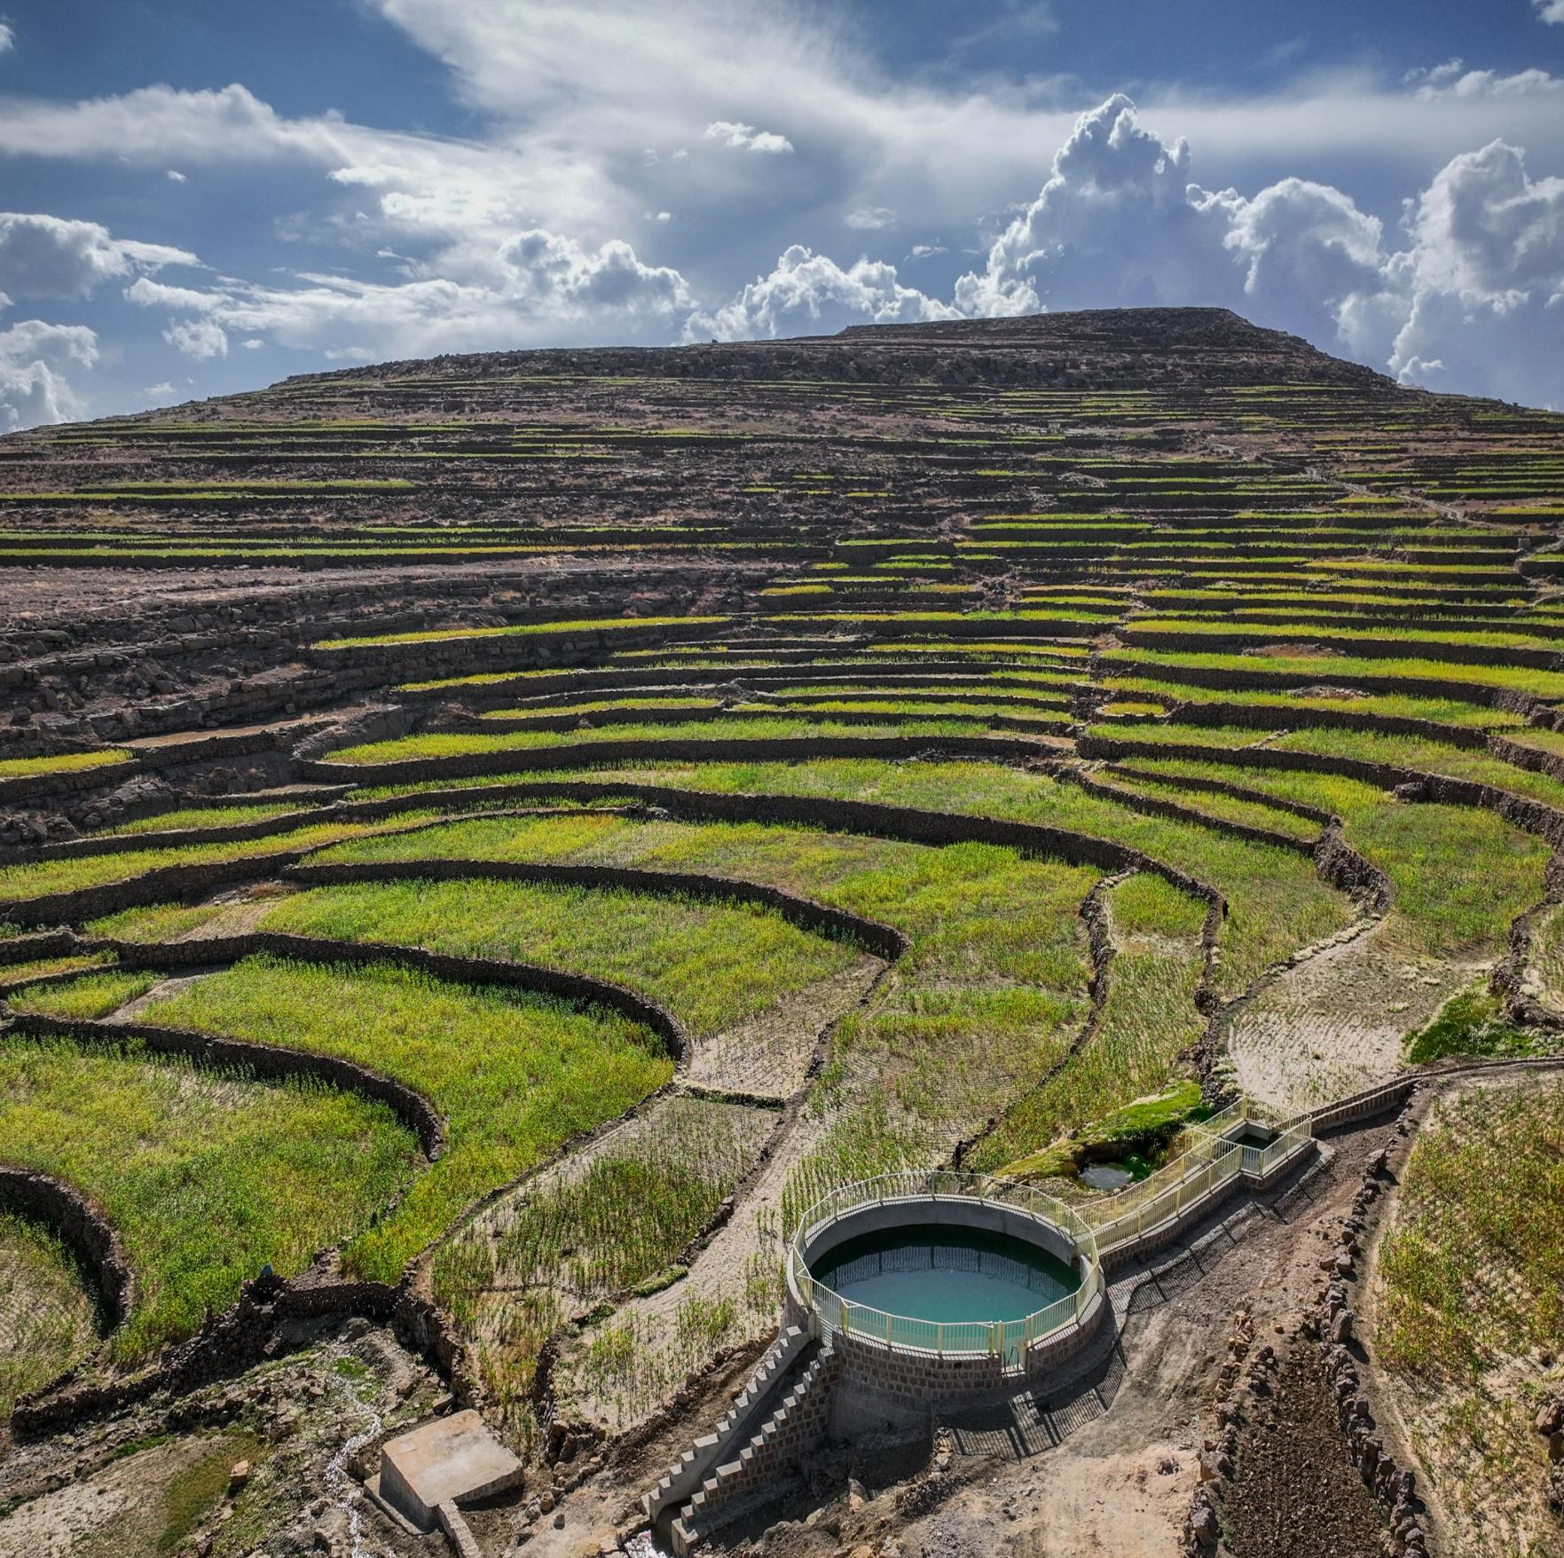
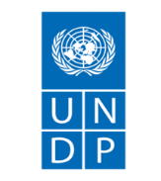
SEMI-ANNUAL PROGRESS REPORT
1 january – 30 jUNE 2025

YEMEN FOOD SECURITY RESPONSE AND RESILIENCE PROJECT (YFSRRP)

Agency Contacts:
Tracy Vienings, International Project Manager tracy.vienings@undp.org
Lina Y. Al-Safi, National Coordinator Lina.Al-Safi@undp.org

August 14, 2025
YFSRRP rehabilitated rain and spring water harvesting tank in Riyash Village, Amran Governorate. Photo credit: UNDP Yemen 2024.
ABBREVIATIONS AND ACRONYMS
AF | Additional Financing
ACAPS  CfW | Assessment Capacities Project  Cash for Work
ESAP  ESCP  ESF  ESMF  ESMP  ESPECRP  ESS  ESRAAC  FAO  GAFSP  GBV (Plan)  GM  IDA  IPs | Environmental and Social Action Plan  Environmental and Social Commitment Plan  Environmental and Social Framework  Environmental and Social Management Framework  Environmental and Social Management Plan  Emergency Social Protection Enhancement and COVID-19 Response Project  Environmental and Social Standards  Environmental and Social Risk Assessment and Clauses  Food and Agriculture Organization  Global Agriculture Food Security Program  Gender-Based Violence (Plan)  Grievance Mechanism  International Development Association  Implementing Partners
IRG  ISM  OHS | Internationally Recognized Government of Yemen  Implementation Support Mission  Occupational Health and Safety
KPI | Key Performance Indicators
LMP  MoAIF  MoFA  PAD  PSEA | Labor Management Procedure  Ministry for Agriculture, Irrigation and Fisheries  Ministry of Foreign Affairs  Project Appraisal Document  Protection from Sexual Exploitation and Abuse
PTW | Permit to Work
PWP  PWD  RRF  RVM  SCMCHA  SDR  SEA  SEP  SFD  SMP  ToR  TPM | Public Works Project  Persons with Disability  Results and Resources Framework  Remote Verification Mechanism  Supreme Council for the Management and Coordination of Humanitarian Affairs  Special Drawing Rights  Sexual Exploitation and Abuse  Stakeholder Engagement Plan  Social Fund for Development  Security Management Plan  Terms of Reference  Third-Party Monitoring
TTL | Task Team Leader
WB | World Bank
YFSRRP  YKB | Yemen Food Security Resilience Response Project  Yemen Kuwait Bank

Table of Contents
1. OPERATING ENVIRONMENT SUMMARY 5
1. Security Issues & Access 5
2. Interaction with authorities 7
2. SUMMARY OF MAIN ISSUES AND KEY ACHIEVEMENTS 7
3. PROGRESS BY COMPONENT / SUBCOMPONENT 10
Output 1: Improving agricultural production infrastructure and building climate resilience (SFD) 10
Output 2: Small-scale agricultural production community infrastructure rehabilitated (PWP) 14
4. Enhance effective geographic targeting and improved linkages between Project Components 18
5. Component 5: Project management and knowledge management 19
6. OPERATIONS 19
3. Procurement plan: 19
4. Budget Status 19
7. IMPLEMENTATION OF ENVIRONMENTAL AND SOCIAL FRAMEWORK 21
5. Environmental and Social Framework (ESF) Status 21
6. Environmental and Social Plans and Risk Assessments 21
7. Conflict Sensitivity 21
8. Environmental and Social Safeguard Monitoring Indicators 22
9. Incidents and Accidents 22
10. Capacity Building Trainings and Awareness 23
11. Field Visits 24
12. Gender Mainstreaming 24
13. Grievance Mechanism (GM) 26
14. Labor Management Procedure 26
8. MONITORING AND EVALUATION 27
15. Monitoring and Verification by UNDP Project Management Team (PMT) 27
Third-Party Monitoring: 30
Engineering Quality Assurance and Verification 30
Financial Spot Check 31
16. UNDP MIS Development for Project Management and Geo-bundling Initiatives 33
9. OTHER ISSUES REQUIRING ATTENTION 34
17. Restructuring of activities 34
18. Results reporting 34
19. Reallocations between components and/or expenditure categories: 34
20. Possible funding gaps: N/A 34
10. STATEMENTS ON ALLEGATIONS 34
11. PROGRESS TOWARDS PROJECT RESULTS FRAMEWORK 35
12. COMMUNICATION 36

ANNEXES:
Annex 1: Social Safeguard and Environmental Report

OPERATING ENVIRONMENT SUMMARY

Security Issues & Access

FTO re-designation of the Sana’a-based Houthis:
In March 2025, the United States re-designated the Houthis as a Foreign Terrorist Organization (FTO), significantly increasing legal, financial, and operational risks in areas under Houthi control. This move led to heightened compliance requirements, banking disruptions, and delays in fund transfers to implementing partners, particularly in the North. Several banks relocated their headquarters to Aden to mitigate sanction exposure, further complicating access to financial services across conflict lines.
To address these risks, UNDP implemented a range of mitigation measures including shifting transactions to non-sanctioned banks, limiting cash advances, adopting direct payment and reimbursement modalities, and ensuring alignment with OFAC General Licenses for humanitarian activities. These efforts aimed to maintain programme continuity while safeguarding compliance and minimizing disruption to YFSRRP operations.
Escalations by USA and Israel against the Houthis:
The Houthis escalated missile and drone attacks on Red Sea shipping in response to the Gaza conflict. The United States launched an operation with a series of targeted airstrikes against Houthi military infrastructure aiming to safeguard international maritime navigation.
By April, a de-escalation agreement mediated by Oman allowed U.S. ships safe passage, easing tensions. Israel also conducted retaliatory strikes on Houthi-linked sites in Yemen. The escalation raised significant regional tensions and disrupted global shipping routes. Although YFSRRP operations were not directly affected, the situation underscored the need for ongoing risk monitoring and adaptive planning amid volatile regional dynamics.
Banking Crisis and Its Operational Impacts on YFSRRP:
In early 2025, Yemen’s banking sector faced severe disruptions due to escalating tensions between the Central Banks in Aden and Sana’a, compounded by international sanctions. The de-licensing of key banks, including the UN's primary partner International Bank of Yemen (IBY), led to liquidity shortages and restricted access to funds. Sanctions on Yemen Kuwait Bank (YKB) and the FTO re-designation of the Houthis further complicated transactions, risking fund freezes and compliance challenges.
In response, UNDP and other UN agencies shifted to alternative banks - Kuraimi Islamic Bank and Yemen Commercial Bank, introduced direct payment and reimbursement methods, and explored additional channels like money exchange networks. Coordination with both Central Banks of Yemen (CBYs), continued donor dialogue, and contingency banking options were also pursued. While these measures have stabilized operations for now, the financial landscape remains fragile and will require close monitoring and adaptive planning going forward.
Bank-Imposed Liquidity Charges
During the reporting period, UNDP Yemen assessed the impact of new liquidity charges (up to 1.75 percent) imposed by commercial banks on US$ transactions, driven by ongoing market constraints. These charges affect the value of project funds, and several donors have confirmed them as ineligible for reimbursement.
Following consultations with Implementing Partners (IPs), UNDP agreed to continue US$ disbursements, with IPs responsible for negotiating any associated charges and converting funds to YER or SAR at agreed exchange rates. Reverting to YER payments was deemed riskier due to currency volatility and liquidity challenges, especially in the North. UNDP and IPs continue to monitor the situation and will adjust as needed to uphold compliance and delivery efficiency. These developments have adversely affected the overall atmosphere in the humanitarian and development sectors, however communication and project implementation resumed with no major impact. UNDP and the World Bank (WB) closely monitor the impact of these developments on operations, and plan to reconvene as necessary to reassess strategies and operational plans in response to the evolving situation.
For YFSRRP, the Social Fund for Development (SFD) has no project accounts managed under Yemen Commercial Bank, the Public Works Project (PWP) has one account with YKB with the amount of US$ 30,192.63 remaining frozen in the bank. High level communication is in progress to ensure the release of the frozen amount along with other project funds in accordance with the roles, restrictions and directives of the imposed sanction.
Close engagement with IPs and other stakeholders, with regular follow up and engagement to monitor the situation and develop long-term solutions to these challenges, is ongoing. YFSRRP provides regular cash position updates to the WB.
Third-Party Monitoring Agencies (TPMA):
The suspension of the Moore Yemen, the project’s TPMA, is still in effect and has affected the process of data collection for the regular TPM. In response to this and to ensure proper arrangements are in place, the WB and UNDP agreed to an alternative and innovative arrangement to cover the TMP project requirements both technically and operationally through the deployment of a Quality Assurance Engineering firm and a Spot Check Firm (see Section 6: Monitoring & Evaluation).
Official Movement and Access:
Yemeni national staff are allowed to fly out of Sana’a on UN-operated flights after obtaining a travel permit from concerned authorities. More restrictions are imposed on female national staff’s travel both domestically and out of the country. Female national staff are required to travel with a male escort (first degree relative or husband) or obtain official, endorsed written consent from a male relative for the travel, which in most cases is not a guarantee of travel facilitation by the security travel authority at Sana’a airport or check points in case of road travel.
The situation worsened with Israeli airstrikes on Sana’a airport severely damaging the infrastructure and destroying remaining commercial airplanes. Sana’a airport is currently closed for commercial flights as of May 6th, 2025, and all commercial flights are rerouted once again to Aden airport.
No major access or security challenges were reported in any of the target locations under component 1 by the IPs or the UNDP project team. No security incidents or access constraints were reported by the IPs during the reporting period.

Interaction with authorities
UNDP ensures the involvement of all concerned stakeholders including authorities in the process of the identification and endorsement of the sub-projects, and the endorsement of the selected community committee members. In addition, UNDP is also working closely with local authorities to develop local plans and ensure that the interventions are responding to the needs of the target locations.
Both IPs were enlisted to be administratively under a Government Ministry/Entity, namely SFD under the Ministry of Social Affairs and Labor and PWP under the Ministry of Local Administration.
In response, SFD has communicated with its partners and the new government, receiving official assurances that SFD's independence will be respected in accordance with its formulation by presidential decree. PWP has also discussed arrangements with the new government to maintain its independence.
Project partners continue to coordinate with concerned authorities - both the Houthis and the Internationally Recognized Government (IRG). SFD has established a special liaison committee responsible for working with relevant authorities, as well as maintaining direct communication with local authorities and agricultural offices in all governorates through SFD branches. The committee's primary role is to establish effective channels of communication with the relevant authorities, promptly addressing any issues that may arise. In such cases, the local authorities and agricultural offices intervene to resolve these matters and facilitate the necessary procedures related to projects and SFD interventions across all governorates.
PWP continues to maintain constant cooperation and coordination with concerned authorities and stakeholders to ensure smoother and more effective implementation of interventions.

SUMMARY OF MAIN ISSUES AND KEY ACHIEVEMENTS
During the reporting period from 1 January to 30 June 2025, SFD successfully completed 18 sub-projects totaling US$2,852,187.30. The 66 identified sub-projects under the Parent Fund (PF) are fully completed as reported in the last biannual report for the period ending 31 December 2024 at a total of US$13,233,418.85.
As of 30 June 2025, SFD completed 84 sub-projects since the project started totaling US$ 16,083,861.
PWP on the other hand already had completed 24 sub-projects from the PF earlier in 2024 totaling US$2,387,931.02 in addition to 18 sub-projects completed during the reporting period totaling US$ 2,010,375.
As of 30 June 2025, PWP completed 42 sub-projects since project start totaling US$ 4,398,306.
Overall, the project has successfully completed 126 sub-projects totaling US$ 20,482,167 as of June 2025, 109 sub-projects are under implementation totaling US$ 21,256,149 and 19 under contracting for a total of US$ 2,010,000.
By the end of the reporting period, the above interventions under the project resulted in the generation of 38,773 temporary employment opportunities, out of which 3,840 were for female beneficiaries, representing 73 percent of the revised project end target of 52,900. This was met through generating 1,211,411 workdays, out of which 128,623 were for female beneficiaries, representing 78 percent of the revised project end target of 1,547,400.
The 126 completed agricultural production infrastructure sub-projects have resulted in community benefits that included 189 kilometers of paved rural roads; 159,247 cubic meters of constructed and improved rainwater harvesting tanks; 7,873 hectares of improved and protected lands; 80,804 meters of constructed and improved irrigation canals; and 11,188 hectares of lands irrigated.
As a result of the above interventions, 14,744 farmers have improved access to agricultural land (3,153 female farmers), representing 109 percent of the total revised target of 13,500. In addition, 16,409 farmers have improved access to water resources to cultivate their lands (3,634 female farmers), representing 64 percent of the total target of 25,700.
During the reporting period an interim WB support mission was held from 27 to 30 January 2025. The mission discussed several key issues, such as the effective geographic targeting and improved linkages between Component 1 and Component 2, with a focus on enhancing smallholder farm households’ access to water resources in addition to other thematic UN partner agency specific issues.
A full-fledged Implementation Support Mission (ISM) was held from 22 to 30 April 2025. Table below shows progress against agreed action points.

Action Points | Progress
Component Linkages: Operationalize the integration of irrigation  (Comp. 1), production (Comp. 2.1), and input support packages for 14 prioritized schemes. Revised proposal due by 22 May, with implementation starting mid-June | UNDP prefinanced the implementation of the required assessment. SFD completed field work and report finalized (attached to this biannual Report)
Project Restructuring: Send to the Bank restructuring request FAO, UNDP, WFP letters articulating proposed areas for restructuring to enhance June 30 and ICRC achievement of the PDO. | Restructuring Proposal submitted to enhance effective geographic targeting and improved linkages between Project Components with a focus on enhancing smallholder farm households’ access to water resources”
Establish a monthly M&E coordination meeting starting 17 June 2025, to ensure continuous progress tracking and technical follow-up. | In progress
Finalize and prepare the YFSRRP M&E plan | UNDP M&E plan is annually prepared and there is a discussion around this led by the WB consultant.
Monitor and update the business continuity/contingency plan in the context of the FTO. | In progress on regular basis and as requested by the WB
Spot check and audit reports of IPs. | In progress on regular basis and as requested by the WB
Revisit and strengthen the YFSRRP Results Framework (RF) to ensure alignment in reporting common indicators across different Ips, and to adapt to the evolving operational context to enhance consistency in monitoring and reporting. | UNDP shared the revised RRF for component 1 with FAO as part of the consolidation of UN agencies revision.

PROGRESS BY COMPONENT / SUBCOMPONENT
Component 1: Improving agricultural production infrastructure and building climate resilience
- Expenditure during period 1st January – 31st December 2024, US$10,991,354.97
- Cumulative Additional Fund (AF) expenditure to 30th June 2025, US$23,345,598.14

Output 1: Improving agricultural production infrastructure and building climate resilience (SFD)
SFD’s expenditure for the first half of 2025 is US$8,527,396.56. Cumulative expenditure as of June 30th 2025, is US$16,170,187.17. SFD has successfully completed 18 sub-projects of the total 98 identified sub-projects totaling US$ 20,338,336. The remaining 80 projects totaling US$ 17,486,149 are at different stages of implementation and progress will be reported in the next bi-annual report.
Table 1 below illustrates the status of SFD sub-projects with budget allocation, as per grouping of interventions.

Table 1: Status of SFD Sub-Projects with Budget Allocation (Output 1)
Type of Interventions | Completed Sub-Projects |  | Ongoing Sub-Projects |  | Total
Type of Interventions | No. of SP | US$ Value | No. of SP | US$ Value | No. of SP | US$ Value
Agricultural Land and Terraces Rehabilitated | 5 | 944,728 | 22 | 5,724,977 | 27 | 6,669,705
Irrigation canals Constructed/Rehabilitated | 3 | 507,836 | 21 | 5,447,958 | 24 | 5,955,794
Rural Roads Improved | 1 | 191,541 | 10 | 1,858,150 | 11 | 2,049,691
Improved Water Schemes/Networks (constructed/rehabilitated) | 9 | 1,208,082 | 27 | 4,455,064 | 36 | 5,663,146
Grand Total | 18 | 2,852,187 | 80 | 17,486,149 | 98 | 20,338,336

Table 2: Employment Generation Status per Intervention Type (Output 1)
Interventions | No. of SP | Cumulative No. of workers |  | Cumulative No. of workdays
Interventions | No. of SP | Total workers | Total female workers | Total workdays | Total female workdays
Agricultural Land and Terraces Rehabilitated | 27 | 4,628 | 371 | 116,288 | 9,562
Irrigation canals Constructed/Rehabilitated | 24 | 3,141 | 89 | 76,882 | 1,359
Rural Roads Improved | 11 | 1,561 | 52 | 46,448 | 234
Improved Water Schemes/Networks (constructed/rehabilitated) | 36 | 3,027 | 442 | 148,776 | 30,609
Total | 98 | 12,357 | 954 | 388,392 | 41,764
*The above 98 sub-projects account for SFD’s completed/ongoing sub-projects under the AF. PF is completed as mentioned in earlier section.

Interventions under these sub-projects have had a positive impact on agriculture, benefiting a significant area of agricultural land and a considerable number of households. Ongoing projects include the improvement of rural roads, construction of rainwater harvesting tanks, and enhancement of agricultural land and irrigation canals. These initiatives aim to enhance farmers’ resilience to climate change, optimize irrigation practices, and boost agricultural productivity while ensuring food security.

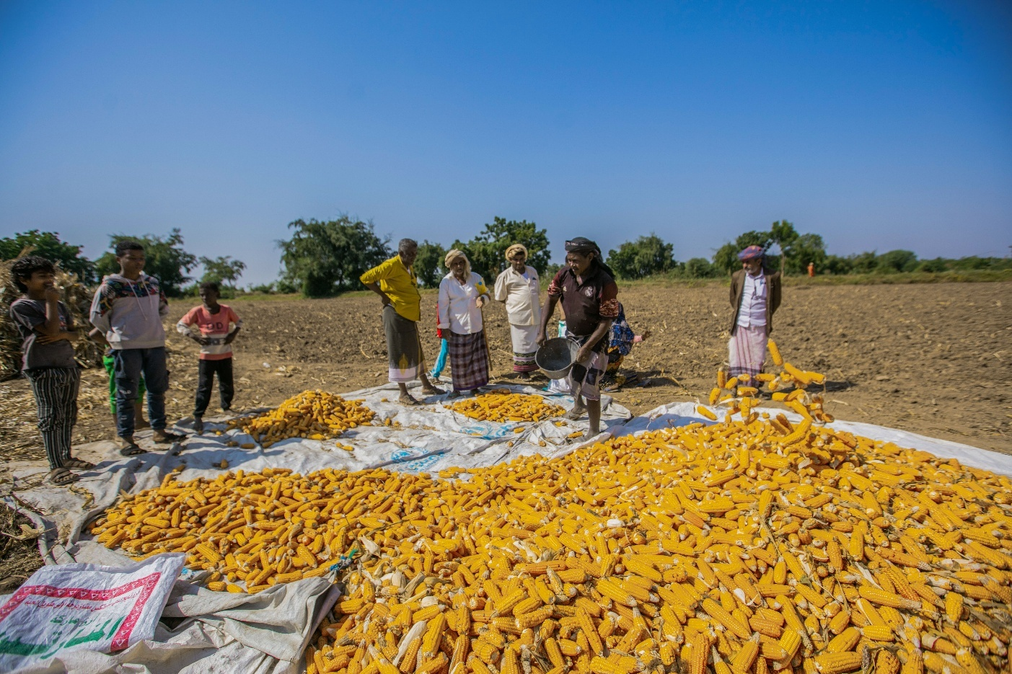
By the end of the reporting period, interventions under output 1 implemented by SFD resulted in the generation of 28,977 temporary employment opportunities out of which 3,448 were for women beneficiaries, representing 76 percent of the revised project end target of 37,900. This was achieved through generating 994,632 workdays, out of which 124,569 were for women beneficiaries, representing 82 percent of the revised project end target of 1,217,400.
Harvest workers sorting corn harvest in Wesab AsSafel, which benefited from YFSRRP rehabilitation and construction of Kubbat Al-Ashraf irrigation canal. Wesab AsSafel, Dhamar Governorate.

Community benefits yielded from the above included 137 kilometers of rural roads paved, and 152,897 cubic meters of rainwater harvesting tanks constructed and improved. 4,285 hectares of land were improved and protected, and 57,203 meters of irrigation canals constructed and improved , with 8,700 hectares of lands irrigated.
As a result, 13,020 farmers now have improved access to agricultural land (3,010 female farmers), representing 130 percent of the total revised target of 10,000. In addition, 12,401 farmers have improved access to water resources to cultivate their land (3,391 female farmers), representing 61 percent of the total revised target of 20,200.
The above reflects achievements resulting from the revised reclassification/recategorization of small holder farmers beneficiaries under irrigation canal interventions. This was discussed and endorsed by the WB following the ISM September 2024 and reflected in RRF target revisions.
Achievements were revised based on the above agreement since the start of the project and is adopted in reporting and updates from 2025 onwards.
These activities contributed to enhancing farmers’ ability to become more climate-resilient, using flood water for irrigation and minimizing the deterioration of agricultural land. Moreover, these interventions increase agricultural productivity and should be complemented by interventions under component 2 implemented by FAO to expand and strengthen the ultimate impact of complementary interventions between the two components as stipulated in the project document.
In summary, where interventions targeting rehabilitation of agricultural production infrastructure and building climate resilience are implemented, this should be complemented by interventions under FAO’s component (e.g. water harvesting structures implemented under UNDP’s component to be complemented by drip irrigation and/or seeds distribution under FAO).
Table 3: Progress Against End Target/SFD
Indicator | Cumulative Achievement | End Target
Persons benefiting from community-based climate resilient infrastructure improvements. (Number) (Beneficiaries of Wages) | 28,977 | 37,900
- Women recipients benefitting from community-based climate resilient infrastructure improvements (Number) | 3,448 | 6,000
Person workdays generated by community-based infrastructure improvement works. (Number) | 994,632 | 1,217,400
- Person workdays generated by community-based infrastructure improvement works benefiting women (Number) | 124,569 | 179,200
Smallholder farm households with improved access to water resources (Number) | 12,401 | 20,200
- Female-headed smallholder farm households with improved access to water resources. (Number) | 3,391 | 5,600
Smallholder farm households with improved access to land resources. (Number) | 13,020 | 10,000
- Female-headed smallholder farm households with improved access to land resources. (Number | 3,010 | 2,400

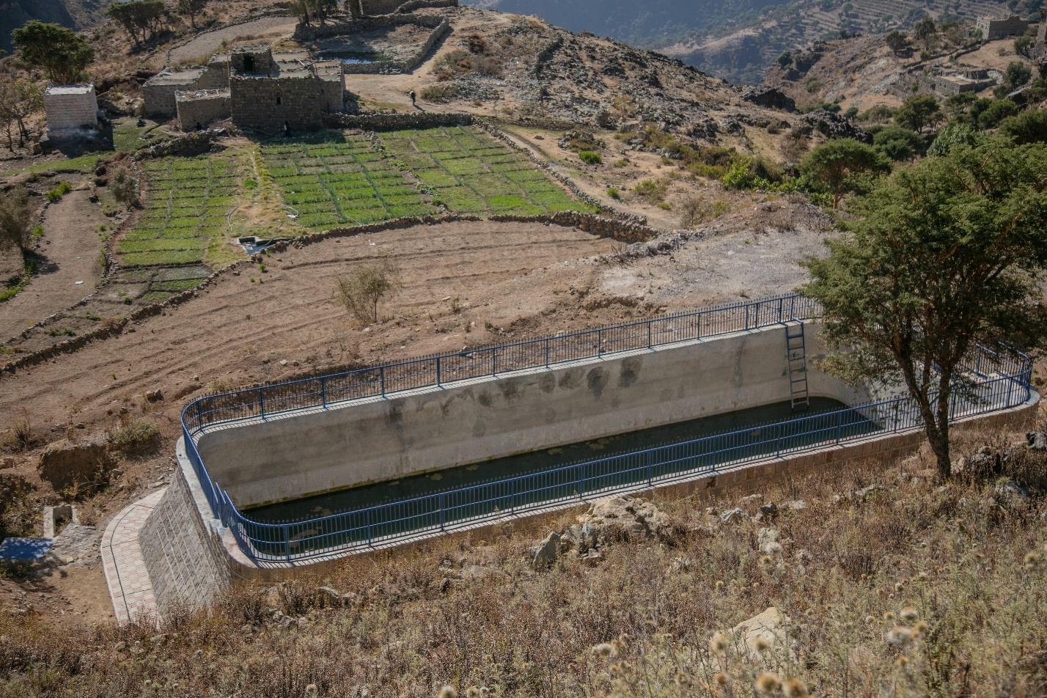
The first of YFSRRP constructed rainwater harvesting tanks supporting sustainable irrigation in Bait Al-Samhi, Utmah District, Dhamar governorate.
Output 2: Small-scale agricultural production community infrastructure rehabilitated (PWP)

- PWP’s expenditure during reporting period 1st Jan – 30th June 2025 is US$1,462,050.19
- Total PWP AF expenditure as of 30th June 2025 is US$4,251,767.95
PWP has successfully completed 18 sub-projects of the total 66 identified sub-projects, totaling US$ 2,010,375, and 29 ongoing projects totaling US$ 3,770,000. The remaining 19 sub-projects, totaling US$ 2,010,000, are at different stages of preparation, and progress will be reported in the next bi-annual report.

Table 4 below illustrates the status of SFD sub-projects with budget allocation, as per grouping of interventions.

Table 4 : Status of PWP Sub-Projects with Budget Allocation (Output 1)
Type of Interventions | Completed Sub-Projects |  | Ongoing Sub-Projects |  | Under preparation |  | Total
Type of Interventions | No. of SP | US$ Value | No. of SP | US$ Value | # of SP | US$ Est. Value | No. of SP | US$ Value
Agricultural Land and Terraces Rehabilitated | 6 | 782,708 | 13 | 1,740,000 | 5 | 405,000 | 24 | 2,927,708
Irrigation canals Constructed/Rehabilitated | 6 | 592,176 | 8 | 1,195,000 | 7 | 970,000 | 21 | 2,757,176
Rural Roads Improved | 3 | 261,164 | 6 | 575,000 | 2 | 190,000 | 11 | 1,026,164
Improved Water Schemes/Networks (constructed/rehabilitated) | 10 | 374,327 | 2 | 260,000 | 5 | 445,000 | 10 | 1,079,327
Grand Total | 18 | 201,0375 | 29 | 3,770,000 | 19 | 2,010,000 | 66 | 7,790,375
s

Table 5 : Employment Generation Status per Intervention Type (Output 1)
Interventions | No. of SP | Cumulative No. of workers |  | Cumulative No. of workdays
Interventions | No. of SP | Total workers | Total female workers | Total workdays | Total female workdays
Agricultural Land and Terraces Rehabilitated | 24 | 2,602 | 59 | 62,494 | 150
Irrigation canals Constructed/Rehabilitated | 21 | 2,643 | 55 | 54,937 | 487
Rural Roads Improved | 11 | 628 | 16 | 16,015 | 205
Improved Water Schemes/Networks (constructed/rehabilitated) | 10 | 759 | 26 | 16,316 | 206
Total | 66 | 6,632 | 156 | 149,762 | 1,048
* The above 66 account for PWP’s identified sub-projects under the AF with 18 completed, 29 ongoing sub-projects and the remaining 19 sub-projects are still under preparation.

By the end of the reporting period, interventions under output 2 resulted in the generation of 9,796 temporary employment opportunities, out of which 392 were for female beneficiaries, representing 65 percent of the revised project end target of 15,000. This was met through generating 216,779 workdays, out of which 4,054 were for female beneficiaries, representing 66 percent of the revised project end target of 330,000.
Community benefits yielded from the above included 52 kilometers of paved rural roads and 6,350 cubic meters of constructed and improved rainwater harvesting tanks. 3,588 hectares of improved and protected lands was achieved, and 23,601 meters of constructed and improved irrigation canals and 2,488 hectares of lands irrigated.
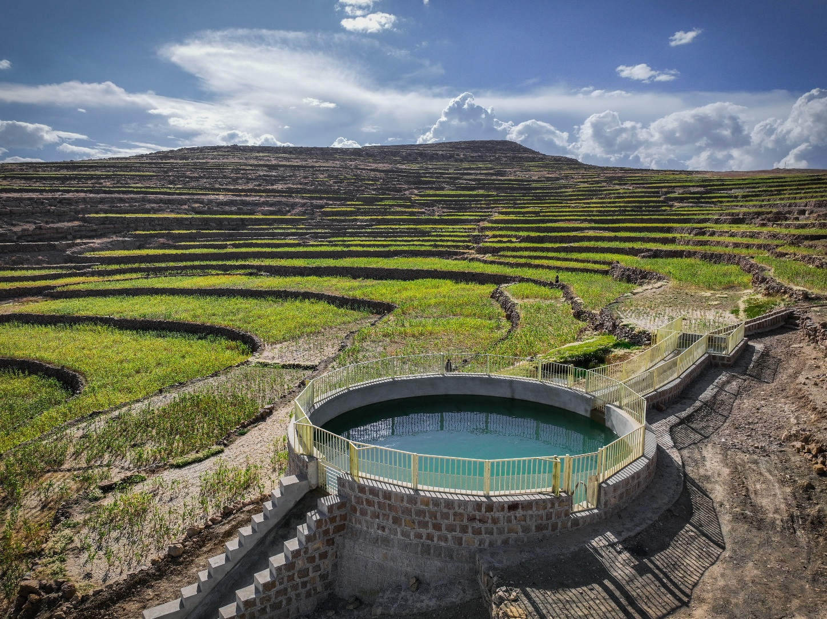
As a result of the above, 1,724 farmers have improved access to agricultural land (143 female farmers), representing 49 percent of the total revised target of 3,500. In addition, 4,008 farmers have improved access to water resources to cultivate their lands (243 women farmers), representing 73 percent of the total revised target of 5,500.
YFSRRP rehabilitated rain and spring water harvesting tank in Riyash Village, Amran governorate. Photo credit: UNDP Yemen 2024.
The above reflects revised achievements resulting from the reclassification/recategorization of small holder farmer beneficiaries under irrigation canal interventions. This was discussed and endorsed by the WB following the ISM in September 2024 and reflected in RRF target revisions.
Achievements were revised based on the above agreement from the start of the project and reflected in the report and will be adopted in all reporting from this point onward.
These activities contributed to enhancing farmers' ability to become more climate-resilient, using flood water for irrigation and minimizing the deterioration of the agricultural land. Moreover, these interventions increase agricultural productivity and should be complemented by interventions under component 2 implemented by FAO, to maximize the overall impact of complementary interventions between the two components, as stipulated in the project document.
As indicated in earlier sections, where interventions targeting the rehabilitation of agricultural production infrastructure and building climate resilience are implemented, they should be complemented by interventions under FAO’s component (e.g. water harvesting structures implemented under UNDP’s component be complemented by drip irrigation and/or seeds distribution under FAO).
Through the Community Contracting modality adopted by PWP, the capacity of small community contractors has been strengthened, enabling them to compete for larger contracts.
Female contractors are encouraged, and their capacity supported, to tender for civil works contracts. For example, two sub-projects for the establishment of two water tanks in Saber Al-Mawadim, Taiz Governorate, were awarded to two female contractors.

Table 6: Progress Against End Target/PWP
Indicator | Cumulative Achievement | End Target
Persons benefiting from community-based climate resilient infrastructure improvements. (Number) (Beneficiaries of Wages) | 9,796 | 15,000
- Women recipients benefitting from community-based climate resilient infrastructure improvements (Number) | 392 | 1,000
Person workdays generated by community-based infrastructure improvement works. (Number) | 216,779 | 330,000
- Person workdays generated by community-based infrastructure improvement works benefiting women (Number) | 4,054 | 11,500
Smallholder farm households with improved access to water resources (Number) | 4,008 | 5,500
- Female-headed smallholder farm households with improved access to water resources. (Number) | 243 | 400
Smallholder farm households with improved access to land resources. (Number) | 1,724 | 3,500
- Female-headed smallholder farm households with improved access to land resources. (Number | 143 | 300

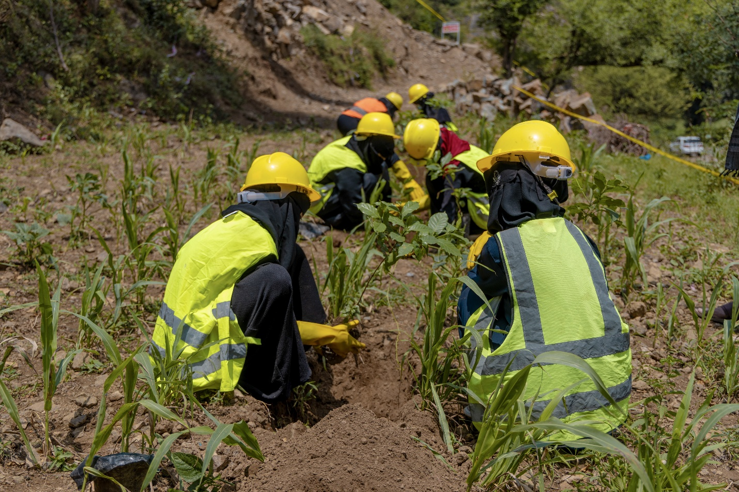
Women participation in plantation of coffee trees and reinstating coffee farms in Talouq area after the construction of rainwater harvesting tanks by YFSRRP in Sabr Al-Mawadim District, Taiz Governorate.

Enhance effective geographic targeting and improved linkages between Project Components
The Mid Term Review (MTR) of the Project, held in September 2024, and the following Technical Discussions in January 2025, highlighted that the complementarity envisaged between Components 1 and 2 was not evident. The MTR recommended that in order to materialize “effective geographic targeting and improved linkages between Components, with a focus on enhancing smallholder farm households’ access to water resources” and to improve synergies among project activities and enhance impacts, Component 1 activities-particularly water harvesting interventions-should be linked with agricultural production support through the provision of suitable seeds for beneficiaries (Component 2.1) and the installation of climate-smart irrigation technologies such as drip irrigation (Component 3.1). These linkages also provide an opportunity to reinforce rural women’s economic empowerment under Component 3.2 by ensuring that improved water access and productive infrastructure contribute to enabling women-led agricultural and nutritional enterprises—such as home gardens, poultry units, and small food processing activities—thereby supporting household nutrition, food security, and income diversification. It was agreed during the MTR that UNDP, in collaboration with SFD and PWP, would review water harvesting infrastructure locations and identify locations where such linkages could be established.
To that end, UNDP, FAO, SFD & PWP undertook an extensive exercise to identify potential joint locations to work on the required synergies. Several detailed technical discussions involving FAO took place, resulting in a list of potential locations focusing on water harvesting interventions under component 1 that can be complemented by component 2 interventions. 14 high-potential schemes were prioritized across 6 districts (9 SFD schemes and 5 PWP schemes). This selection process is also intended to ensure that resources are directed toward the most impactful and sustainable water harvesting initiatives. These interventions will be covered under a surplus from SFD under FAO’s component.

Component 5: Project management and knowledge management
UNDP’s expenditure for the first half of 2025 is US$1,001,908.22. Cumulative expenditure until 30th June 2025, is US$2,923,643.02 of the AF.
Staffing: International staff, including the Project Manager and the three specialists, are on board and these posts are cost-shared with the Emergency Social Protection Enhancement and COVID-19 Response Project (ESPECRP). YFSRRP is also supported by the existing staff of the other WB-funded project ESPECRP - mainly the Aden team and the safeguard and gender teams, the communication and knowledge team. Technical Working Groups for the SES and the M&E are active.

OPERATIONS

Procurement plan:
The YFSRRP Procurement Plan and Reporting tool for the end of Q2 has been updated and shared with the WB team (attached for ease of reference).
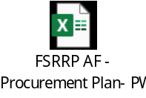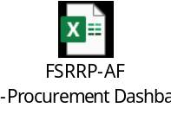

Budget Status
The table below shows expenditure during the reporting period, 1 Jan-30 June 2025, and the cumulative expenditure.
Table 7: Budget Status/IP/AF
IP | Description | Grant Allocation | Delivery
IP | Description | Grant Allocation | Total expenditure  (01 Jan – 30 June 2025) | Cumulative Expenditure as of 30 June 2025 | Overall Burn Rate (%)
SFD | 1) Implementing community-based Cash for Work activities. | 2,820,151.00 | 131,408.58 | 1,672,435.68 | 59%
SFD | 2) Implementing community Contracting Sub-projects. | 16,307,832.00 | 6,894,889.37 | 10,963,389.24 | 67%
SFD | 3) Supervising implementation, conducting, trainings. | 1,716,614.00 | 416,854.66 | 1,182,022.87 | 69%
SFD | 4)Shared Cost between Sub-projects/Activities. | 1,226,153.00 | 439,371.41 | 946,077.37 | 77%
SFD | 5) SFD's Operating expenses | 2,452,306.00 | 644,872.54 | 1,406,262.01 | 57%
SFD | SFD TOTAL | 24,523,056.00 | 8,527,396.56 | 16,170,187.17 | 66%
PWP | Activity 1: Implementing community based civil works for the rehabilitation of community infrastructure | 8,505,697.00 | 1,260,824.73 | 3,358,249.19 | 39%
PWP | Activity2: Conducting consultancy and monitoring services to support the implementation | 1,063,228.00 | 127,180.25 | 437,613.20 | 41%
PWP | Activity3: Operating Expenses | 1,063,228.00 | 74,045.21 | 456,055.56 | 43%
PWP | PWP TOTAL | 10,632,153.00 | 1,462,050.19 | 4,251,917.95 | 40%
UNDP | UNDP Direct Operating Cost | 3,130,505.29 | 478,513.57 | 1,811,940.70 | 58%
UNDP | UNDP GMS 5% | 1,914,285.71 | 523,394.72 | 1,111,702.32 | 58%
UNDP | UNDP Total | 5,044,791.00 | 1,001,908.29 | 2,923,643.02 | 58%
TOTAL |  | 40,200,000.00 | 10,991,355.04 | 23,345,748.14 | 58%

IMPLEMENTATION OF ENVIRONMENTAL AND SOCIAL FRAMEWORK

Environmental and Social Framework (ESF) Status
UNDP updated the fifth draft of the Stakeholder Engagement Plan (SEP), incorporating data collected from January to December 2024. This draft was shared with FAO to gather updates from other involved UN agencies. The finalized SEP was submitted to the WB team in January 2025.

Environmental and Social Plans and Risk Assessments
Since the start of the YFSRRP AF through June 2025, a total of 28 Environmental and Social Action Plans (ESAPs), 12 from SFD and 16 from PWP, have been developed for YFSRRP activities and submitted to the WB. These ESAPs cover 100 sub-projects with a combined cost of $15,133,030. All ESAPs have been reviewed and approved by the WB.
In addition, 26 Environmental and Social Risk Assessment and Clauses (ESRAACs), 21 from SFD and 5 from PWP, were developed for the YFSRRP activities and submitted to UNDP, covering 57 sub-projects with a combined cost of $12,092,988. UNDP has approved and cleared all the ESRAACs and submitted a copy to the WB. For more details, please refer to Annex 1 “Detailed Environmental and Social Risk Management Report”.

Table 8: Status of ESAP and ESRAAC developed during the reporting period.
IP | Number of ESAPs/ESRAACs | Number of Sub- Project | Cost of sub-project | Cleared Plans
SFD | 33 | 98 | $ 19,886,681 | 33 ($ 19,886,681)
PWP | 21 | 59 | $ 7,327,881 | 21 ($ 7,327,881)
Total | 54 | 157 | $ 27,214,562 | - ($ 27,214,562)

Table 9: Developed plans per category
 | ESAP | ESRAAC
Plan per category | 28 | 26
Projects | 100 | 57
Cost US$ | $ 15,133,030 | $ 12,092,988

Conflict Sensitivity
UNDP ensures Ips’ adherence to no-conflict and “DO NO HARM” approaches in their activities, thereby ensuring that any related issues are flagged and responded to in a timely manner. During the reporting period, no conflict cases were recorded by the IPs. No conflict-related case was recorded through the UNDP toll-free number.

Environmental and Social Safeguard Monitoring Indicators

The table below demonstrates the progress on the environmental and social monitoring indicators during the reporting period.
Table 10: Safeguard Monitoring Indicators
Area of safeguard indicator | SFD | PWP | TOTAL
Numbers of work Permits issued | 1,444 | 1,423 | 2,867
Numbers of OHS and Emergency plan awareness taken place | 936 | 58 | 994
Number of GM awareness sessions were taken place | 737 | 61 | 798
Number of awareness sessions on CoC for workers were held | 562 | 112 | 674
Number of gender and GBV awareness sessions provided to community members | 564 | 61 | 625
Numbers of field visits conducted in the reporting period | 69 | 98 | 167
Number of the Community committee reports submitted to IPs | 173 | 0 | 173
Number of workers under than 18 years | 0 | 0 | 0
Numbers of incidents happened during the work | 3 | 0 | 3

Incidents and Accidents
During the reporting period, a total of three minor accidents were reported by SFD, while no incidents were recorded by PWP. These cases, although minor, reflect an encouraging level of maturity in the reporting and risk management systems. The incidents were reported from the governorates of Al Hodeidah, Aden, and Dhamar. All incidents were managed promptly on-site using first-aid kits, and no project delays or material losses were reported as a result. Importantly, there were no fatalities or serious injuries recorded. UNDP has verified the reported data submitted by the IPs. For more details, please refer to Annex 1 “Detailed Environmental and Social Risk Management Report”.

Table 11: Summary of incidents/IP
IP | Sub-projects number | Working-Hours (bi-annual) | Working-Hours (Cumulative) | No of Accidents (bi-annual) | Cumulative No of Accidents | Percentage of Accidents per W.H
SFD | 73 | 616,630 | 6,290,027 | 3 | 19 | 0.97
PWP | 34 | 604,152 | 1,751,056 | 0 | 11 | 0
Cumulatively, a total of 30 accidents have been reported across sub-project sites, with 19 incidents recorded at SFD sites and 11 at PWP sites. These included 26 minor incidents, three moderate incidents, and one near miss. Most of these incidents were attributed to lapses in adherence to the health and safety measures outlined in the Environmental and Social Frameworks and site-specific Occupational Health and Safety (OHS) instructions. While the incidents did not result in significant harm, UNDP has emphasized the importance of strict compliance with OHS protocols. IPs and contractors have been reminded to ensure safe working positions, proper handling of equipment and tools, and ongoing supervision of site activities.
No critical incidents involving of fatality, lost time due to injury, acts of violence, or child labor cases were reported during the reporting period. Additionally, no cases of Gender-Based Violence (GBV), Sexual Exploitation and Abuse (SEA), or security-related incidents were reported at any of the sub-project sites.

Capacity Building Trainings and Awareness
The capacity building activity aims to equip the relevant staff of IPs with the necessary knowledge, skills, and resources to effectively mainstream gender throughout the project life cycle and successfully implement strategies and actions to prevent Gender-Based Violence and Sexual Exploitation and Abuse. It also seeks to enhance institutional capacities to increase the participation of women in Cash for Work interventions by designing women-friendly activities, raising awareness about challenges hindering women's participation, discussing suitable solutions to bridge gaps, and strengthening partnerships and coordination with relevant agencies. Additionally, the activity aims to document and replicate success stories and best practices.
The cumulative status of safeguard capacity building provided by SFD and PWP for different target groups is presented in the following tables:
Table 12: Environmental and Social Risk Management Awareness
Awareness | SFD |  |  |  | PWP
Awareness | OHS, Gender & GBV |  | GM |  | Environmental, Social, CoC, OHS, and GM
Awareness | Male | Female | Male | Female | Male | Female
Consultant Engineer | 206 | 1 | 28 | 0 | 40 | -
Resident Engineer | 393 | 5 | 33 | 0 | 79 | -
Contractors | 514 | 18 | 0 | 0 | 138 | 8
Workers | 6,587 | 135 | 1,563 | 459 | 3,988 | 204
Community Committees | 721 | 114 | 137 | 21 | 61 | 12
Local community | 1,451 | 131 | 405 | 751 | 288 | 63
Total | 9,872 | 404 | 2,166 | 748 | 4,594 | 287
Table 13: Environmental and Social Risk Management Training
IP | Topic | Date | Location | Participants
 |  |  |  | Male | Female
PWP | Environment, Social Safeguard, and OHS | Jan. 25 | Amran | 16 | -
PWP | Environment, Social Safeguard, and OHS | Jan. 25 | Dhamar | 39 | 3
PWP | Environment, Social Safeguard, and OHS | May. 25 | HQ | 18 | 4
SFD | Gender, OHS, Social, Environment | Jan. 25 | HQ | 44 | 31
SFD | Gender, OHS, Social, Environment | Jan. 25 | Hodeida | 32 | -
SFD | Gender, OHS, Social, Environment | Jan. 25 | Sana’a | 26 | -
SFD | Gender, OHS, Social, Environment | Jan. 25 | Hajjah | 28 | -
SFD | Gender, OHS, Social, Environment | Feb. 25 | HQ | 92 | 42
SFD | Gender, OHS, Social, Environment | Feb. 25 | Hajjah | 17 | -
SFD | Gender, OHS, Social, Environment | Feb. 25 | Aden | 56 | 31
SFD | Gender, OHS, Social, Environment | Feb. 25 | Hadramout | 16 | 5
SFD | Gender, OHS, Social, Environment | Feb. 25 | Sana’a | 19 | 4
SFD | Gender, OHS, Social, Environment | Feb. 25 | Aden | 51 | 14
SFD | Gender, OHS, Social, Environment | Apr. 25 | Hadramout | 24 | 2
SFD | Gender, OHS, Social, Environment | May. 25 | HQ | 15 | 41
SFD | OHS | May. 25 | HQ | 46 | 10
SFD | Gender, OHS, Social, Environment | May. 25 | HQ | 59 | 12
SFD | Gender, OHS, Social, Environment | Jun. 25 | Hadramout | 23 | 3
SFD | Gender, OHS, Social, Environment | Jun. 25 | Hadramout | 21 | 2
Total |  |  |  | 642 | 204

Field Visits
During the first half of 2025, a total of 172 field visits were conducted to monitor compliance with safeguard instruments at sub-project locations during the implementation of sub-project activities. Of these, 5 visits were conducted by the UNDP team, 69 by the SFD team, and 98 by the PWP team.
The major findings from the site visits were:
- 100 percent of sub-projects visited have an ESMP on site.
- 98.7 percent of sub-projects visited have emergency plans posted in visible places.
- 99.4 percent of sub-projects visited had First Aid Kits (FAK) available.
- 98.4 percent of sub-projects visited displayed GM posters.
- 100 percent of sub-projects visited had complaints boxes available.

For the sub-projects where the social safeguard and environmental requirements were not fully met, the IP staff, consultants and the contractors were briefed about the importance of 100 percent compliance and instructed to provide the missing equipment and information at each sub-project location.

Gender Mainstreaming
UNDP and the IPs took practical steps to strengthen economic inclusion and enhance women’s participation across various project activities. In this context, UNDP held a dedicated workshop in February 2025 to discuss and validate a set of activities under the Cash for Work (CFW) component that are socially acceptable and physically appropriate for both women and persons with disabilities (PWDs). These activities aim to expand the range of economic opportunities available at the field level, representing a key step toward increasing women’s participation and promoting inclusive economic engagement. Additionally, UNDP held a discussion with IPs in June 2025 and encouraged them to involve women contractors under the community contracting approach with a certain percentage of project activities to be exclusively announced for them. This initiative will enable women to compete among themselves, creating more equitable opportunities to participate and succeed in community contracting, thereby enhancing their economic empowerment in this sector. UNDP conducted monthly meetings with the IPs, aimed at coordinating complementary interventions to maximize impact, enhance women’s empowerment, and ensure sustainable outcomes.

SFD: During the reporting period, SFD conducted 562 awareness-raising sessions on the Code of Conduct (CoC), GBV, and prevention and mitigation measures for PSEA. These sessions targeted consultant and resident engineers (599 male, 6 female), contractors (514 male, 18 female), workers (6,587 male, 135 female), community committees (721 male, 114 female), and the local community (1,451 male, 131 female). Additionally, SFD conducted a refresher training for its personnel on the updated SEA policy incorporating stricter measures to ensure the safety and protection of beneficiaries on the ground targeting 334 staff (224 men and 110 women), 273 consultant engineers (221 men and 52 women), and 98 resident engineers (91 men and 7 women).

In addition, 171 community members, 50 percent of whom were women, attended the public consultations and participated in needs assessments to identify priority projects that address community needs and bridge existing gaps. Additionally, 3 women were selected from the 11 elected community committee members and assigned a vital role in supervising project implementation. A total of 570 households benefited from improved access to markets, including 205 female-headed households. This enhanced market access has strengthened livelihood opportunities, increased household incomes, and promoted the economic empowerment of women, particularly those heading their households.

SFD safeguards focal points conducted a field visit during which 26 female workers and beneficiaries were randomly selected for interviews to assess women's participation, working conditions, job satisfaction, safety, and awareness. The assessment indicated that 80.77 percent of the women who participated in the needs assessment confirmed the selected projects reflected their actual needs. Furthermore, 92 percent stated they feel completely safe at the worksite, and 100 percent confirmed they received awareness of the complaints reporting mechanism. In addition, 46 percent reported being directly engaged in project activities, either as technical or social consultants, or in roles suitable to their physical capabilities, such as site cleaning and tree planting. 38 percent stated that they are highly satisfied with their wages, which they used to provide for their families' basic needs and improve their livelihoods.

PWP: PWP conducted 45 awareness and training sessions on gender and GBV/SEA prevention and mitigation measures targeting 69 male supervisor and technical engineers, 109 contractors (104 male and 5 female) 3040 workers (2854 male 186 female), 631 community committee members (547 male and 84 female). During the reporting period, 186 women were given work opportunities to participate in the project activities to benefit from wage employment. The activities that were assigned for women were designed to suit their physical capacities and included removing harmful trees, water supply and water spraying tasks and cooking for workers. During the reporting period, 3 public consultations were conducted with the participation of 156 community members (122 men and 34 women) based on these consultations, 3 community committees were established, and 22 persons were elected (18 men and 4 women) and assigned to play a strategic role in monitoring project implementation and to address any issue that may occur. Additionally, PWP supported women to be targeted in the project interventions not only as workers but also as contractors. 3 women won four tenders across three sub-projects. During this quarter, all of them successfully implemented the projects they were assigned to. PWP also helped establish a women's entrepreneurship section within the Chamber of Commerce and Industry in Sana’a. It is headed by one of the women who received contractor training through the project. It now provides regular training sessions for its female members, who have shown great enthusiasm to continue working in the construction sector. For more details, please refer to Annex 1 “Detailed Environmental and Social Risk Management Report”.

Grievance Mechanism (GM)
During the reporting period, a total of 323 complaints were recorded. Of these, 196 complaints were related to SFD sub-projects. However, only 102 out of 196 were found to be credible after verification. Among the complaints related to SFD sub-projects, 99 percent (194 out of 196) were submitted by males, and 1 percent (2 out of 196) by females. Nearly 43 percent were related to disputes over financial dues, followed by 21 percent associated with inclusion in the selection.
For PWP sub-projects, 127 complaints were recorded during the reporting period. Of these, 99 percent (126 out of 127) were submitted by males, while 1 percent (1 out of 127) were submitted by a female. Most of the complaints (76 percent) were related to disputes over financial dues.
Of the 323 complaints recorded, 90 percent (291 out of 323) were resolved and closed, while 10 percent (32 out of 323) remain pending. Among the resolved complaints, 93 percent were addressed within 14 days, excluding those related to financial issues which took longer to gather additional information, time and resources to address. SFD and PWP are currently conducting a verification process for the remaining 32 pending complaints, which are expected to be resolved shortly. Table 8 below provides a summary of the complaints categorized by their nature.
Table 14: Received complaints during the reporting period by category
Contractual | ES/OHS | Financial | General | Inclusion in the Selection | Technical | Corruption and Fraud | Labor and Working Conditions
37 | 13 | 182 | 14 | 41 | 27 | 3 | 6
12% | 4% | 56% | 4% | 13% | 8% | 1% | 2%

Labor Management Procedure
During the reporting period, there were no changes to the core Environmental and Social Risk Management team of the project: no new recruitment and no separation of staff. The table below summarizes the number of workers and contractors involved in the sub-project implementation from January to July 2025.
Table 15: Environmental and Social Risk Management Team and Workers
ESRM Team and Workers | UNDP | SFD | PWP
Direct Workers (safeguard staff + technical staff) | 14 | 325 | 123
Consultants | 6 | 150 | 27
Contracted Workers | - | 10,782 | 985
Suppliers | - | 4 | 0
Community Committee Members | - | 11 | 35

UNDP and the IPs ensured that no child labor or forced labor was included in the workforce by verifying government-issued ID cards and providing orientation on the Code of Conduct (CoC) during the recruitment process.

MONITORING AND EVALUATION
Monitoring and evaluation during the reporting period were central to guiding implementation, improving quality, and aligning activities with community priorities. Insights from field missions, third-party monitoring, and MIS data analysis informed both operational and strategic adjustments. For example, findings on PPE conditions led to immediate replacements and routine inspection procedures; visits to flood-prone zones prompted the need for new protective structures; and recommendations on inclusive labor participation led to shaping culturally appropriate roles for women in the implementing sub-projects. Quality assurance assessments resulted in additional measures to strengthen erosion control and formalizing bidder site visits, while financial spot checks drove improvements in procurement sequencing, tender evaluation, and reporting alignment.
In addition, MIS and sub-projects list enhancements, guided by monitoring insights, have also improved system security, and integration. These adaptive measures at the different levels of the project demonstrate the project’s commitment to evidence-based decision-making and ensure that lessons learned through M&E are systematically integrated into ongoing and future interventions.

Monitoring and Verification by UNDP Project Management Team (PMT)

By June 2025, the UNDP Project Management Team (PMT) conducted monitoring and verification visits to 45 sub-project sites across seven governorates. The recent visits during the reporting period, specifically to Lahj and Al-Dhali’ Governorates, covered six sub-projects. The field missions were designed to monitor agricultural infrastructure sub-projects, foster direct engagement with community stakeholders, and provide constructive feedback to IPs to improve implementation outcomes and long-term sustainability further.
The May 2025 field mission was a joint effort between UNDP, SFD and PWP. It aimed to assess the progress of implementation, infrastructure quality, safeguard compliance, and community engagement. The team employed a diverse methodology involving site observations, community consultations, focus group discussions, asset verification, and documentation review.
A key summary of findings is as follows:

Protection of Agricultural Land and Rehabilitation of Irrigation Canals: Implemented by SFD
The sub-projects implemented across Tur Al-Baha, Al-Madharaba/Ras Al-Ara, and Wadi Al-Sila aim to construct agricultural land protection walls and rehabilitate irrigation canal entrances. These interventions are critical for preventing soil erosion, protecting vital farmland, and enhancing agricultural productivity in vulnerable rural areas. The field mission visited various sub-project locations, including sites with 70 percent implementation completed in Tur Al-Baha, 20 percent in Al-Madharaba/Ras Al-Ara (early stage), and an ongoing implementation site in Wadi Al-Sila, with emphasis on priority needs.
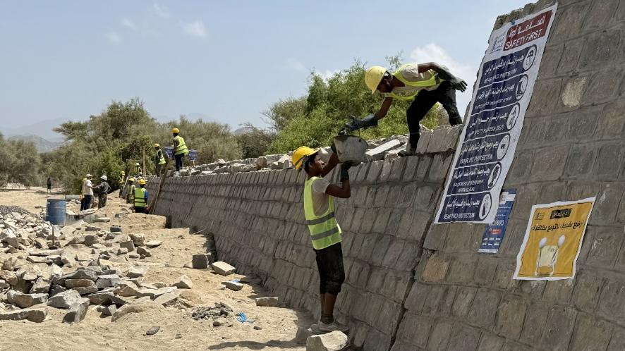
Community Prioritization and Participation: Community committees across all sites consistently identified agricultural protection walls and gabions as top priorities, particularly to safeguard canal entrances and farmland. These needs have been longstanding and previously unmet (e.g., in Tur Al-Baha, since 2006). Committees were actively engaged in project selection, implementation, monitoring, and in some cases, maintenance planning, fostering strong local ownership.
300-147701 Construction of protection walls in Waid Al-Shu’bah Al-Sofla, Al-Shu’bah Al-Sofla, Tur Al-Baa, Lahj.

Labor and Local Capacity: Wage workers were selected from within the community using fair and transparent criteria, prioritizing those with the greatest need. Skilled labor was sourced from nearby areas when local expertise was unavailable. In total, 150 workers have been engaged in Tur Al-Baha alone, though all are men. Contractors were primarily local, contributing to the enhancement of local capacity and economic benefits. In Al-Madharaba, working hours were adjusted (6–10 a.m., 3–5 p.m.) to mitigate risks associated with high temperatures.
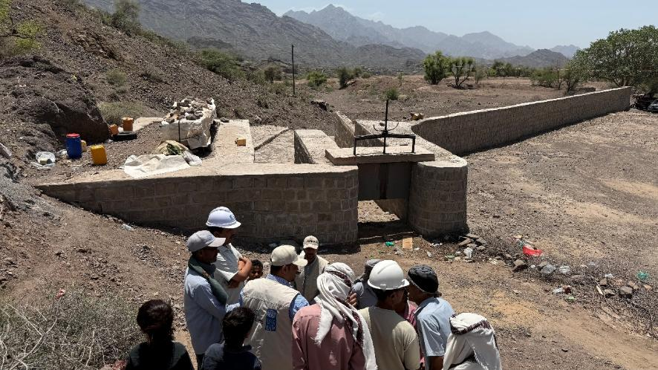
Coverage and Impact: The sub-projects collectively target the protection of more than 200 hectares of farmland (e.g., 120 ha in Tur Al-Baha, 95 ha in Wadi Al-Sila), supporting cultivation of various crops and improving rural livelihoods. These efforts are expected to boost economic resilience for farmers, especially when integrated with other geo-bundled initiatives in the same areas.
300-14669 - Protecting farmland and rehabilitating irrigation canals in Al-Damnah and Al-Haql, Wadi Al-Saylah, Dhali district, Dhali.

Technical Compliance and Safeguards: Key safeguard documents (ESAPs, permits, GM records, training logs, worker lists) were present and properly maintained. Worksite safety standards were met across all sites- clearly demarcated work areas with controlled access; display of safety signs, caution tapes; and emergency contact information; and site activities followed Occupational Health and Safety (OHS) protocols. Personal Protective Equipment (PPE) was generally in use, though in Tur Al-Baha, PPE was reported to be in poor condition. The issue was flagged and reported to SFD with documentation. GM processes were well communicated to workers and communities, and complaints were reported. Supervisors and consultants demonstrated awareness of their responsibilities and held regular meetings and risk assessments.
Challenges and Recommendations: The field mission team recorded several challenges and made the following recommendations in consultation with the respective community committee members and field representatives of the IPs.
Enhance Worker Safety through PPE Management: Immediate replacement of damaged or poor-condition PPE is essential. Implement routine inspections to monitor PPE quality and ensure that all workers consistently have access to safe, appropriate, and functional protective gear.
Strengthen Flood Mitigation Measures: In areas where flood risks persist (e.g., behind the main stone protection walls), conduct detailed technical assessments to identify vulnerable zones. Construct additional protective structures (such as gabions or secondary walls) to safeguard canal entrances and surrounding farmland. Actively involve local farmers in planning to enhance relevance and promote long-term community ownership.
Promote Inclusive Labor Participation: The IP is strongly encouraged to develop and implement strategies to engage women wage workers in sub-project activities. Design roles that are culturally appropriate, aligning with local norms and values, and meaningful and safe, ensuring dignity and relevance of work. Tailor roles to women’s capacities, considering their specific skills, availability, and needs. Encouraging women's participation not only promotes gender inclusion but also enhances the socioeconomic impact of the sub-projects.

Rehabilitation and Protection of Agricultural Canals: Implemented by PWP
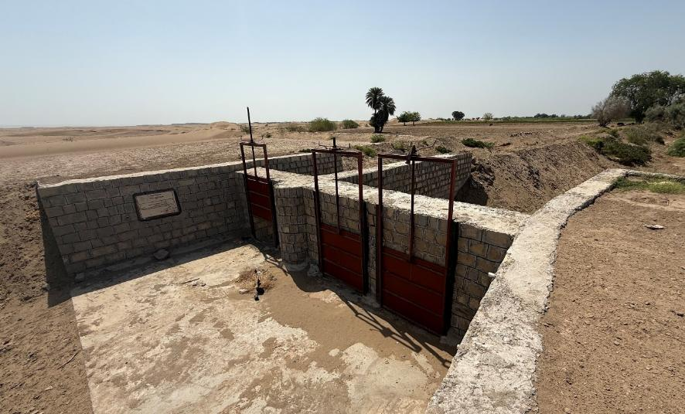
The rehabilitation and protection of the Abr Al-Mansouri Canal, Abr Jadeed Al-Azbiya Canal, and Abr Jadeed Al-Mjuhfa Canal aim to enhance the sustainability and productivity of agricultural lands in the region. These interventions are intended to protect farmland, preserve canal infrastructure, and promote sustainable farming practices. They form part of a broader geo-bundling strategy implemented by the SFD under the YFSRRP, alongside three complementary sub-projects under the ESPECRP project. These interconnected efforts share similar activities, aiming to maximize impact and effectively respond to the needs of the local agricultural community.
10-6-17068 Rehabilitation and Protection of Abr Al-Mansouri Canal in Tuban district, Lahj governorate.

Key findings: Members of the community committee highlighted that constructing agricultural protection walls to safeguard canal entrances and adjacent lands is a top priority for local farmers. Across the three geo-bundled sub-projects, the construction of these protection walls has improved approximately 120 hectares of farmland and 6,300 meters of irrigation canals, supported the cultivation of various crops, and enhanced the economic well-being of 135 farmers. The community committee actively engaged in the project’s selection, implementation, and monitoring processes. Interviewed committee members confirmed that wage workers were selected through a fair and transparent process, prioritizing individuals with the highest levels of need within the community.
Recommendations: In some sections of the protection walls along the Abr Jadeed Al-Mjuhfa Canal, the wall height needs to be increased to adequately match the level of the protected soil behind them. Consider diversifying geo-bundled interventions further to address a broader range of community needs and enhance overall impact in the targeted areas.
Field Mission Report can be found in the link: YFSRRP Field Mission Report

  - Third-Party Monitoring:
Following the suspension of the original TPM agency by the Houthis in March 2024, UNDP, in coordination with the WB, instituted an alternative third-party monitoring mechanism. This includes the engagement of an engineering consulting firm for infrastructure quality assurance and an audit firm for financial spot checks.

Engineering Quality Assurance and Verification
Across the reporting period, the engineering firm conducted quality assurance assessments for a total of 87 sub-projects implemented by SFD and PWP. The inspections highlighted a generally high level of compliance with technical and environmental standards, while also identifying recurring challenges such as delays caused by external factors (e.g., banking disruptions, labor availability). These insights are feeding into a broader learning process for adaptive implementation and sustainability planning.

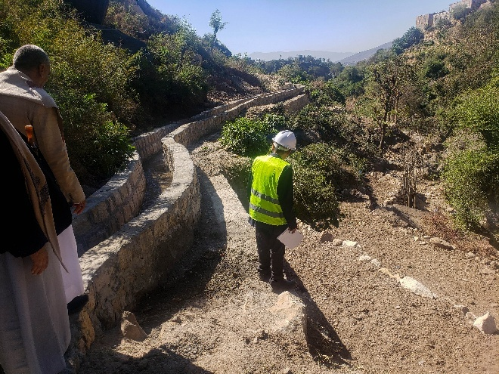
During the first quarter of 2025, the engineering firm visited 41 sub-projects, assessing their alignment with approved technical designs, environmental and OHS compliance, and climate resilience measures. The firm utilized a structured methodology combining desk reviews, standardized checklists, site inspections, and stakeholder interviews. The assessment found that 72 percent of SFD sub-projects and 69 percent of PWP sub-projects were fully compliant with quality standards. The remaining sub-projects exhibited minor deficiencies, including issues like insufficient joint pointing in water cisterns and delays linked to banking restrictions. Importantly, IPs responded promptly to the engineering notices issued, undertaking necessary corrective actions. The report also recommended integrating seasonal climate patterns into future project planning, especially to avoid implementation delays during peak rainfall. It emphasized the value of proactive supervision and called for more detailed procurement plans at the sub-project level to streamline future assessments.
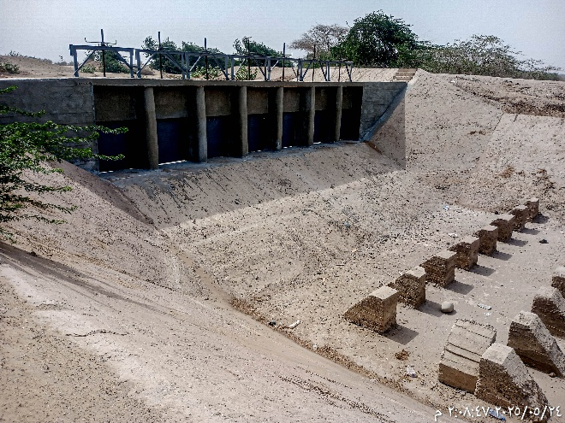
The engineering consulting firm, AMICON, conducted quality assurance assessments for 46 sub-projects implemented by SFD and PWP in the second quarter of 2025. The assessment confirmed that most sub-projects demonstrated solid technical performance, adherence to quality standards, and integration of climate resilience features, despite facing operational delays and external constraints. For SFD, 34 sub-projects were assessed. While 92 percent of ongoing works met quality benchmarks and 86 percent of completed or handed-over projects were functional, delays (ranging from 2 to7 months) were common, particularly in agricultural land protection. Design compliance stood at 82 percent, with most deviations promptly addressed via Quality Assurance Notices. Climate resilience features were present in 85 percent of cases, though erosion risks were noted in areas where mortar had been omitted. For PWP, 12 sub-projects were reviewed. Technical compliance was strong (92 percent), and all sub-projects incorporated robust flood-resilient design elements. However, two ongoing sub-projects’ activities were temporarily inactive during the visits due to delayed disbursements. All completed works were operational.
Overall, the Engineering Quality Assurance firm recommendations focused on improving erosion control, formalizing bidder site visits, and better aligning fund flows with seasonal conditions. Despite challenges, the Q2 assessment confirmed that both IPs are on track to deliver sustainable infrastructure outcomes under YFSRRP, with continued monitoring planned to reinforce quality and climate resilience.
Engineering Quality Assurance Reports (Q1 and Q2 2025) can be found at the following link: YFSRRP TPM Quarterly Reports

Financial Spot Check
An independent audit firm was contracted to conduct a spot check of financial records and controls for the same sample of sub-projects that were evaluated under the Engineering Quality Assurance (EQA) exercise. The objective was to verify the integrity of financial documentation, ensure consistency with the approved workplans and budgets, and assess adherence to procurement and disbursement protocols by the IPs.
The spot check covered the financial performance of 2024 and was conducted between February and March 2025. It followed the International Standard on Related Services (ISRS) 4400, which governs engagements to perform agreed-upon procedures regarding financial information. The audit focused on internal control systems, financial reporting practices, and the alignment between reported expenditures and actual implementation activities.
Key Findings: The spot verification team found that SFD maintained strong financial management practices, with no material findings or discrepancies. Documentation was complete, properly authorized, and aligned with the approved procurement and financial procedures. The spot check confirmed that SFD’s expenditures were accurately recorded and supported by verifiable documentation.
While PWP exhibited overall compliance, several areas for improvement were identified. Specifically, the audit found that in some cases, advance payments made to community groups responsible for tendering and contracting were prematurely recorded as expenditures without sufficient supporting documentation at the time of reporting, creating temporary inconsistencies in financial statements. Additionally, certain sub-projects initiated tender-related activities prior to formal agreement signing, resulting in procedural irregularities. The assessment also revealed inconsistent application of contractor selection criteria—some community-based selection was solely on price, while others considered additional qualitative factors such as past experience or social benefit.
Recommendations: The following recommendations were made by the assigned financial spot verification firm to enhance financial oversight and ensure compliance with UNDP and WB:
- Align reporting with contractual requirements: PWP is advised to ensure that all recorded expenditures are backed by appropriate documentation and aligned with the timing of contract execution.
- Strengthen procurement sequencing: Communities must adhere strictly to the procedural sequence, avoiding the initiation of any procurement-related activities prior to official agreement signing.
- Standardize tender evaluation frameworks: A uniform set of evaluation criteria should be introduced and disseminated across all communities to ensure fairness, transparency, and consistency. These criteria should balance cost-efficiency with quality, experience, and socio-economic impact.
- Capacity building: Additional training is recommended for community committees and IP focal points on financial reporting, procurement compliance, and documentation standards to reduce discrepancies and ensure accountability.

The spot check affirmed that the IPs are operating within an acceptable accountability framework. However, the observations—particularly for PWP—highlight the need for continued oversight, technical guidance, and capacity strengthening to improve financial controls and ensure sustainable, transparent implementation.
Spot Check Verification Reports can be found in the link: YFSRRP TPM Quarterly Reports
In ecent spot check exercise, UNDP realized that conducting these checks on a quarterly basis may be less effective. Some sub-projects take up to six months to complete, which means quarterly reviews often come too early, with insufficient progress or spending to assess. In some cases, the same FACE Form ends up being reviewed more than once, leading to repetitive work and limited added value. Additionally, considering the nature of spot checks, which differs from engineering assurance in both scope and timing, UNDP found that a six-month approach would be more suitable than a quarterly one. It allows sufficient time for project activities to progress, provides more meaningful and complete samples for review, and ensures a more efficient use of time and resources. For these reasons, UNDP recommend shifting to semi-annual spot checks moving forward.

UNDP MIS Development for Project Management and Geo-bundling Initiatives

Enhancing MIS Security and Readiness for Full Implementation: Building on the successful Go-Live of the MIS at the end of 2024, the first half of 2025 has focused on strengthening the system’s security and ensuring its readiness for full-scale implementation. As part of the commitment to maintaining a secure and reliable platform, UNDP conducted a Web Application Penetration Test (WAPT) prior to the system’s official rollout. This assessment aimed to identify any potential vulnerabilities that could affect system performance or data protection. The WAPT has been completed, and the findings currently under review. The UNDP MIS team is actively working with UNICC to address the identified issues to ensure the MIS meets the highest standards of security and functionality. These efforts are being carefully managed to avoid disrupting ongoing system use and data entry.
Way forward for completing the Resolution of all WAPT-identified issues: conduct a follow-up review to validate the fixes and confirm system stability; continue onboarding project data and expand system usage across relevant teams; and monitor system performance and user feedback to guide further enhancements. These actions are essential to ensuring that the MIS remains a robust and scalable tool for managing UNDP’s WB-funded projects. The system continues to offer a centralized, transparent, and efficient approach to project tracking, reporting, and decision-making.
Development of the Geo-bundling MIS: UNDP has finalized the development of a comprehensive Geo-bundling MIS to enhance the planning, monitoring, and oversight of WB-funded geo-bundling projects in Yemen. This advanced system is regularly updated with data on intervention areas, sub-projects, resilience plans, partner feedback, and the number of sub-projects managed by each implementing partner. Equipped with interactive mapping features, the MIS aligns with geo-bundling standards, enabling stakeholders to visualize project locations and coordinate plans based on community needs.
The Geo-bundling MIS facilitates effective communication and information exchange among partners, empowering them to make informed decisions and prioritize initiatives that address the most pressing local challenges. The system's data portal is populated with supporting documents and resources, providing comprehensive information to all partners involved. Regular updates ensure the MIS remains an indispensable tool for monitoring, coordination, and organizational efficiency, ultimately enhancing the effectiveness of geo-bundling interventions.
Overall, while challenges remain, the establishment and ongoing enhancement of the MIS represent a significant step forward in improving the coordination and execution of geo-bundling projects, ultimately aiming to maximize their impact on vulnerable communities. In conjunction with the impact evaluation exercise, GB MIS seeks to enhance its support by offering comprehensive mapping and spatial analysis services. This initiative will focus specifically on the areas selected for the impact evaluation, ensuring that these regions benefit from detailed insights and visual representations that can drive informed decision-making and strategic planning. To access the developed products along with Geo-bundling’s MIS, please refer to the provided links: (a) Yemen Geo-bundling Portal; (b) Geo-bundling Dashboard: (c) GPTA: Data Collection App; (d) SharePoint eDocument site ; (e) Power BI Interactive Report.

OTHER ISSUES REQUIRING ATTENTION

Restructuring of activities
There was no restructuring proposed or requested during the reporting period. There is a growing shift toward graduating from CfW to Community contracting (CC), given that most identified sub-projects focus on medium and large infrastructure interventions.
This is in line with the AF Project Appraisal Document PAD and the approved Implementation Mechanism for YFSRRP stating that the mechanism for implementing infrastructure for land and water will primarily be carried out through the CC approach.

Results reporting
As indicated in earlier sections, the RRF was revised in relation to achievements resulting from the reclassification/recategorization of small holder farmers beneficiaries under irrigation canals interventions. This was discussed and endorsed by the WB following the ISM September 2024 and reflected in RRF target revisions.
Achievements were revised based on the above agreement since the start of the project and are reflected in the report. These revisions will be adopted from this report onward.
The final revision is reflected in Section 9: Progress Towards Project Results Framework.

Reallocations between components and/or expenditure categories:
As indicated above, SFD is transitioning from CfW to more community contracting and national competitive bidding. There is no reallocation implied because they are under the same component budget line.

Possible funding gaps: N/A
Component 1 is currently budgeted until December 2025 under the current financing. UNDP is monitoring SDR status as of end-June 2025 for potential exchange rate gains. While these gains are not expected to be significant, they will be used to cover operational gaps for both IPs and UNDP costs. The operational gap was previously highlighted and discussed with the WB, and the agreement was to use any gains to partially cover these costs.
In light of a potential Additional Fund, the funding gap can be bridged. UNDP is currently looking at covering PWP’s operational funding using surpluses under direct implementation, which the TTL confirmed are at the discretion of UNDP.

STATEMENTS ON ALLEGATIONS
UNDP did not receive any allegations of any type and nor did the IPs.

PROGRESS TOWARDS PROJECT RESULTS FRAMEWORK

Progress towards Project Targets
Results chain | Indicators | Baseline | Progress to 30 June 2025 | Percentage achieved as of 30 June 2025 | End target  (Expected value at project completion)
Intermediate Results Indicators by Components
Improving household incomes through CFW for ag. production infrastructure and climate resilience | Persons benefiting from cash-based transfers (Number) | 0.00 | 38,773 | 73% | 52,900
 | Women recipients benefitting from cash-based transfers (Number) | 0.00 | 3,840 | 55% | 7,000
 | Person work-days generated by emergency Cash for Work schemes (Number) | 0.00 | 1,211,411 | 78% | 1,547,400
 | Person work-days generated by emergency Cash for Work schemes benefiting women (Number) | 0.00 | 128,623 | 67% | 190,700
 | Farmers with improved access to water resources (Number) | 0.00 | 16,409 | 64% | 25,700
 | Female farmers with improved access to water resources (Number) | 0.00 | 3,634 | 61% | 6,000
 | Farmers with improved access to land resources (Number) | 0.00 | 14,744 | 109% | 13,500
 | Female farmers with improved access to land resources (Number) | 0.00 | 3,153 | 117% | 2,700
Project Management and Knowledge Management | Grievances registered and addressed in a timely manner (Percentage) | 0.00

COMMUNICATION
In the first half of 2025, three field visits were organized to Dhamar Governorate to produce a number of impact written stories and videos. Missions to other locations were rescheduled due to the absence and irregularity of rainfall- no rain, no farming, and no crops. In addition, YFSRRP published two quarterly fact sheets, produced a video highlighting the positive impacts of protection walls in Hajjah, and produced a number of visibility roll-up banners, some of which were used during the April 2025 ISM in Amman.
FSRPR Online Media Library:
YFSRRP online media library continues to be updated with high-quality photos, video b-rolls, and video soundbites from field documentations to be used for developing stories, videos, publicizing FSRRP progress and milestones, and future advocacy and communications. The latest updates captured irrigation and rainwater harvesting interventions in Dhamar Governorate. Below is YFSRRP’s Dropbox online media library outline:
01 Food Security Response and Resilience Project (YFSRRP): (main folder)
- 01 YFSRRP in the field
  - 01 Agricultural land improvement
  - 02 Irrigation improvement

  - 03 Water harvesting
  - 04 Rural roads improvement
  - 05 FSRRP team missions to the field
- 02 Communication products
  - 01 Videos
  - 02 Written stories
  - 03 Fact sheets
- 03 YFSRRP updates
  - 01 Fact sheets
  - 02 Infographics/briefs
- 04 YFSRRP visibility
  - 01 YFSRRP Identity package
  - 02 Promotional items
  - 03 Rollup stands
  - 04 WB-UNDP partnership

Communications Coordination meetings with IPs:
Communication coordination meetings continued to take place regularly with UNDP’s IPs during the first half of 2025, enabling efficient planning and coordination of field coverage and the production of joint materials.

Technical Working Group (TWG) with FAO & WFP:
Unfortunately, YFSRRP’s technical work group has not held any meetings recently due to limited capacity within FAO’s Communications team, which serves as the TWG organizer.
YFSRRP Webpage:
YFSRRP’s English and Arabic webpages continue to be reviewed and updated as necessary. They now communicate YFSRRP’s targets, latest progress and achievements as of June 2025.
Communication Products:
Below is a list of YFSRRP’s communication products published and in the pipeline during the first half of 2025:
- Written stories/articles:
Due to irregular rainfall during the first half of 2025, many documentation activities were rescheduled. Nevertheless, YFSRRP produced two written stories promoting the positive impact of the project on local food production:

- Banana and grain harvests benefiting of YFSRRP’s irrigation interventions:
A draft article on the impact of YFSRRP rehabilitation of irrigation canals in Wesab AsSafel, Dhamar Governorate, on the local production of grains and banana.

- Coffee harvests improve benefiting from YFSRRP water harvesting tanks:
A draft article on the improved coffee harvests benefiting from YFSRRP’s constructed and improved water harvesting tanks in Wadi Al-Mayanah, Utmah, Dhamar Governorate.

- Videos:
In the first half 2025, YFSRRP produced three videos, which are still on until the situation improves.

  - Harvesting Banana & grains in Wesab AsSafel, Dhamar:
A draft video focusing on the positive impact of rehabilitated irrigation canals on improving banana and grain farms yields. The PWP & SFD joint intervention video also shows how FSRRP’s interventions not only build farmers’ climate-resilience but also reduce losses and alleviate hardship. Below is Dropbox link to the draft video:
- https://www.dropbox.com/scl/fi/zdj8zjzdrk2tosh2h0g1i/UNDP-2025-FSRRP-Corn-Banana-harvest-in-Dhamar-17.04.2025-Final.mp4?rlkey=6nt3dj6p3bjp0f7pkd80dxt75&dl=0

  - Coffee harvests benefit from improved water harvesting tanks in Utmah, Dhamar:
A draft video highlighting the impact of YFSRRP’s constructed and improved water harvesting tanks by SFD in Wadi Al-Mayanah, Utmah District, Dhamar Governorate, on coffee harvest, farmers’ resilience, and their improved living. Below is Dropbox link to the draft video:
- https://www.dropbox.com/scl/fi/n8tkh0ghemyxplcxix85l/Coffee-Harvest-video-Utmah-Dhamar-DRAFT.mp4?rlkey=bir8197nicws68tvdnskx0799&dl=0

  - YFSRRP protection walls protect farmland and improve food security in Wadi Qesamah, Hajjah:
A draft video on YFSRRP protection walls intervention in Wadi Qesamah, Hajjah Governorate, by PWP. The video highlights the immense damage caused by torrential floods and showcases how FSRRP helps protect farmlands, improve farmers’ resilience to climate change, as well as improve crop yields. Below is a link to the draft video:
- https://www.dropbox.com/scl/fi/pj5hdfs4lcot0kmi3vo2i/FSRRP-protection-walls-in-Wadi-Qesamah-Hajjah-21.04.2026.mp4?rlkey=vnscqv87rwfktj6kmx4dmv8qk&dl=0

- YFSRRP’s fact sheets:
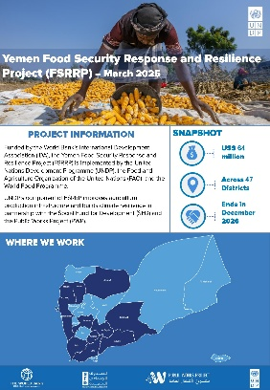
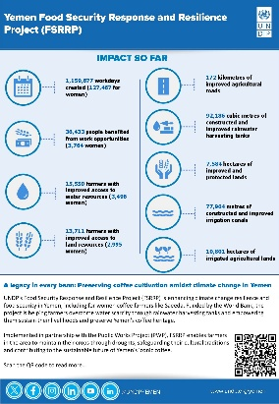
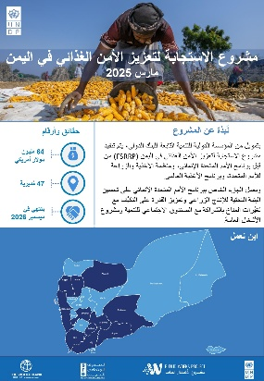
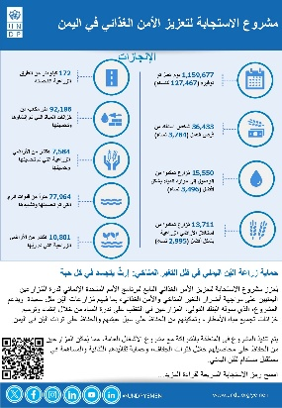
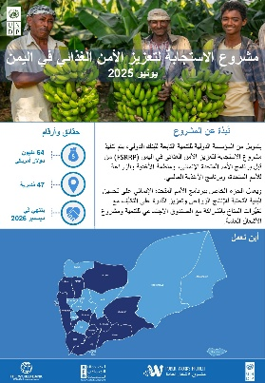
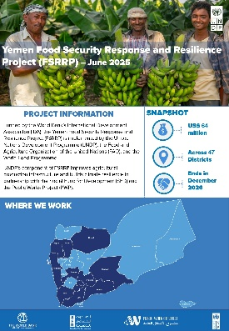
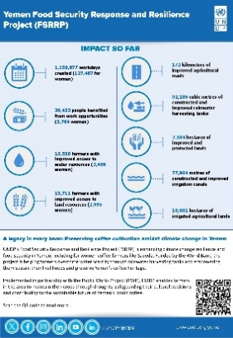
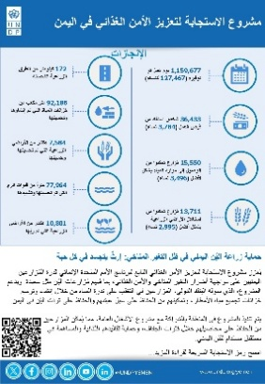
YFSRRP published its 2025 Q1 and Q2 infographic fact sheets communicating up-to-date progress and promoting the project’s impact and achievements. Below are the fact sheet designs and links to the published files:
YFSRRP’s 2025 Q1 fact sheet
YFSRRP’s 2025 Q2 fact sheet
Published fact sheets’ links:
- 2025 Q1 YFSRRP Fact sheet EN
- 2025 Q1 YFSRRP Fact sheet AR
- 2025 Q2 YFSRRP Fact sheet EN
- 2025 Q2 YFSRRP Fact sheet AR

- UNDP-WB Partnership Anniversary campaign:
YFSRRP contributed substantially to the development and launch of the UNDP-World Bank partnership campaign, celebrating eight years of partnership and positive impact in Yemen. The campaign was launched across all UNDP platforms and comprised a promotional video, thematic reels and a booklet showcasing impactful stories from YFSRRP, as well as other current and previous World Bank-supported projects, including the Yemen Emergency Crisis Response Project (YECRP), Emergency Social Protection Enhancement and Covid-19 Response Project (ESPECRP), and Sustainable Fishery Development in Red Sea and Gulf of Aden (SFISH) Project. Below are links to the published materials:

- Promo video:
  - https://x.com/UNDPYemen/status/1858197036664869214
  - https://x.com/UNDPYemen/status/1858177920730055065
  - https://fb.watch/xdBWzcthop/
- Partnership Booklet:
  - https://x.com/UNDPYemen/status/1869404758827778373
  - https://x.com/UNDPYemen/status/1869389656976236558

Partnership Reels:
- Building Back Better
  - https://x.com/UNDPYemen/status/1869835163892625418
  - https://x.com/UNDPYemen/status/1869817831589855629
  - https://www.facebook.com/reel/951587353573438

- Improving Agricultural Productivity for Food Security
  - https://x.com/UNDPYemen/status/1870917043236798644
  - https://x.com/UNDPYemen/status/1870816098754412874
  - https://www.facebook.com/reel/929760525483460

- Investing in Human Capital and Local Community
  - https://fb.watch/xdH9xd2Fq-/
  - https://x.com/UNDPYemen/status/1871621407475683412

- Supporting climate-resilient communities
  - https://x.com/UNDPYemen/status/1873665515677495790
  - https://x.com/UNDPYemen/status/1873648733298311562
  - https://fb.watch/xdHd8z1GNs/

- Fostering Economic Resilience
  - https://x.com/UNDPYemen/status/1874087692738453699
  - https://x.com/UNDPYemen/status/1874056025424486447 https://www.facebook.com/reel/622881963639699

- Sustainable Fishery
  - https://fb.watch/xdC03le9bM/

- Social media:
UNPD, SFD and PWP continue to advocate for and promote YFSRRP’s interventions, progress, achievements, and partnership with the World Bank across their respective platforms, using YFSRRP’s official hashtag- #FSRRP. Below are links to UNDP’s social media posts across its various platforms:
Platform | Link
Twitter | https://x.com/UNDPYemen/status/1875588006842921092
Twitter | https://x.com/UNDPYemen/status/1875612915124011133
Facebook | https://www.facebook.com/watch/?v=593774266942667
Instagram | https://www.instagram.com/p/DEaUmSpvg__/
LinkedIn | https://www.linkedin.com/feed/update/urn:li:activity:7281365016224649216/
Twitter | https://x.com/UNDPYemen/status/1876675213037031701
Twitter | https://x.com/UNDPYemen/status/1876694112109253036
Facebook | https://www.facebook.com/UNDPYEMEN/posts/pfbid062DR3j83PfGqSAooXBopThQaYVdTorRDJFG1K59VGUeEYV3NjunQRMNbSEaRZDabl
Instagram | https://www.instagram.com/p/DEiMJ1zIR75/?img_index=1
LinkedIn | https://www.linkedin.com/feed/update/urn:li:activity:7282463402713624576/
Twitter | https://x.com/UNDPYemen/status/1877286904191693127
Twitter | https://x.com/UNDPYemen/status/1877323874234142795
Facebook | https://www.facebook.com/watch/?v=1613791789218670
Instagram | https://www.instagram.com/p/DEmlRcgCHPq/
LinkedIn | https://www.linkedin.com/company/undp-yemen/posts/?feedView=all
Twitter | https://x.com/UNDPYemen/status/1878109619836633366f
Twitter | https://x.com/UNDPYemen/status/1878124719825891382
Facebook | https://www.facebook.com/reel/559098183787663
Instagram | https://www.instagram.com/p/DEsqyR5JBEv/
LinkedIn | https://www.linkedin.com/feed/update/urn:li:activity:7283901731200000000/
Twitter | https://x.com/UNDPYemen/status/1878487105078247436
Twitter | https://x.com/UNDPYemen/status/1878502201502634459
Facebook | https://www.facebook.com/reel/559098183787663
Instagram | https://www.instagram.com/p/DEwY74DsTsa/
LinkedIn | https://www.linkedin.com/feed/update/urn:li:activity:7284279218513829888/
Twitter | https://x.com/UNDPYemen/status/1879581554395210054
Twitter | https://x.com/UNDPYemen/status/1879614146880344171
Facebook | https://www.facebook.com/watch/?v=3483306021973334
Instagram | https://www.instagram.com/p/DE2W6dNtadv/
LinkedIn | https://www.linkedin.com/feed/update/urn:li:activity:7285302223524257793/
Twitter | https://x.com/UNDPYemen/status/1879936661540512031
Twitter | https://x.com/UNDPYemen/status/1879951756324401656
Facebook | https://www.facebook.com/watch/?v=957531709231574
Instagram | https://www.instagram.com/p/DE5VDUmshUi/
LinkedIn | https://www.linkedin.com/feed/update/urn:li:activity:7285725014434209793/
Twitter | https://x.com/UNDPYemen/status/1881663556858630168
Twitter | https://x.com/UNDPYemen/status/1881691099762405616
Facebook | https://www.facebook.com/reel/950590100346774
Instagram | https://www.instagram.com/p/DFFrrdBBZmy/
LinkedIn | https://www.linkedin.com/feed/update/urn:li:activity:7287449566839279616/
Twitter | https://x.com/UNDPYemen/status/1882389444939940316
Twitter | https://x.com/UNDPYemen/status/1882405422629306545
Facebook | https://www.facebook.com/watch/?v=1336075817524029
Instagram | https://www.instagram.com/p/DFKrJjyCnHu/
LinkedIn | https://www.linkedin.com/feed/update/urn:li:activity:7288158201236049921/
Twitter | https://x.com/UNDPYemen/status/1884296437674230220
Twitter | https://x.com/UNDPYemen/status/1884318542981652650
Facebook | https://www.facebook.com/UNDPYEMEN/posts/pfbid02QKRcFzvrfpgqgZdAgAZVGv2ybMpn7UvtYGYWDphsUuqvFMLLww49A6rSUeFNpcjDl
Instagram | https://www.instagram.com/p/DFYZXdoI-m1/?img_index=1
LinkedIn | https://www.linkedin.com/feed/update/urn:li:activity:7290366427989999616/
Twitter | https://x.com/UNDPYemen/status/1886900180168966458
Twitter | https://x.com/UNDPYemen/status/1886914138993246677
Facebook | https://www.facebook.com/UNDPYEMEN/posts/pfbid0iirQDrqqR8k7W9yxpDjqLnXNWFSeSsmWkfx31B1dvB8b1HA7Ubdd8Pdoz6HQi1Qil
Instagram | https://www.instagram.com/p/DFqiMnuosEZ/?img_index=1
LinkedIn | https://www.linkedin.com/feed/update/urn:li:activity:7292643707965628417/
Twitter | https://x.com/UNDPYemen/status/1888951556881396111
Twitter | https://x.com/UNDPYemen/status/1888974153396396289
Facebook | https://www.facebook.com/UNDPYEMEN/posts/pfbid02mmmitxcZwr3fjBqUoPkM2G84hUTqNfcBEUJcKj1Myv2BFZDcL48DoXCZUCAWnYbEl
Instagram | https://www.instagram.com/p/DF5bu3woY3w/?img_index=1
LinkedIn | https://www.linkedin.com/feed/update/urn:li:activity:7294731606794084354/
Twitter | https://x.com/UNDPYemen/status/1890065439775977500
Twitter | https://x.com/UNDPYemen/status/1890086475301007824
Facebook | https://www.facebook.com/watch/?v=1159067435158578
Instagram | https://www.instagram.com/p/DGBW18oNmEz/
Twitter | https://x.com/UNDPYemen/status/1892503662464839861
Twitter | https://x.com/UNDPYemen/status/1892522083860492394
Facebook | https://www.facebook.com/watch/?v=2059077404567876
Instagram | https://www.instagram.com/p/DGSYUT2iUKi/
Twitter | https://x.com/UNDPYemen/status/1893629311900360909
Twitter | https://x.com/UNDPYemen/status/1893644746985202036
Facebook | https://www.facebook.com/watch/?v=1190241299203934
Instagram | https://www.instagram.com/p/DGanqDvtjoF/
Twitter | https://x.com/UNDPYemen/status/1895911920676565208
Twitter | https://x.com/UNDPYemen/status/1895927018040033509
Facebook | https://www.facebook.com/watch/?v=2654801438050926
Instagram | https://www.instagram.com/p/DGq8h4epJ10/
LinkedIn | https://www.linkedin.com/feed/update/urn:li:activity:7301685984272801796/
Twitter | https://x.com/UNDPYemen/status/1896510636848451983
Twitter | https://x.com/UNDPYemen/status/1896523411020734850
Facebook | https://www.facebook.com/UNDPYEMEN/posts/pfbid02FjfFfUEdYcATr5HPtVqpYjkozdubxWPx7xrHsJji12o2xewPDbVmDWg3aoPdMvCUl
Instagram | https://www.instagram.com/p/DGu_77diRls/?img_index=1
Twitter | https://x.com/UNDPYemen/status/1897376123119657190
Twitter | https://x.com/UNDPYemen/status/1897388856821080400
Facebook | https://www.facebook.com/UNDPYEMEN/posts/pfbid02vBqhMPKPcxHqP4wbXwY6ULdgoi9E49uRZvQfrrE8KCuL533kLgvw41xQoQWG2qq1l
Instagram | https://www.instagram.com/p/DG1J-XWt7uw/?img_index=1
Twitter | https://x.com/UNDPYemen/status/1904136119974776836
Twitter | https://x.com/UNDPYemen/status/1904230013550952779
Facebook | https://www.facebook.com/watch/?v=1376438750437593
Instagram | https://www.instagram.com/p/DHlMNTIMjwN/
Twitter | https://x.com/UNDPYemen/status/1906796770190856543
Twitter | https://x.com/UNDPYemen/status/1904230013550952779
Facebook | https://www.facebook.com/photo/?fbid=1066859138809898&set=a.615648677264282
Instagram | https://www.instagram.com/p/DH4KilNtjb0/
Twitter | https://x.com/UNDPYemen/status/1909541772927132043
Twitter | https://x.com/UNDPYemen/status/1909562645566337173
Facebook | https://www.facebook.com/photo/?fbid=1073203434842135&set=a.615648677264282
Instagram | https://www.instagram.com/p/DILrvP8tWsF/?img_index=1
Twitter | https://x.com/UNDPYemen/status/1914041561173860443
Twitter | https://x.com/UNDPYemen/status/1914057392465080394
Facebook | https://www.facebook.com/UNDPYEMEN/posts/pfbid02VZqDJKoZoHRAztxBYLnDa679VXNEGWaMVX78oopSL7XMz5A6f2Rr2A76zv9ztH7rl
Instagram | https://www.instagram.com/p/DIrrGoPNLBR/?img_index=1
Twitter | https://x.com/UNDPYemen/status/1914764565809680446
Twitter | https://x.com/UNDPYemen/status/1914783781921464588
Facebook | https://www.facebook.com/UNDPYEMEN/posts/pfbid0xBqzrs9QX1ZEGCpWhS8j4UA2jG6jFsEGgScY34yai3RmYA3z4QT7q1wjamMf6syKl
Instagram | https://www.instagram.com/p/DIwfeGaNPuW/?img_index=1
Twitter | https://x.com/UNDPYemen/status/1915008941345411508
Twitter | https://x.com/UNDPYemen/status/1915027823900663903
Facebook | https://www.facebook.com/photo/?fbid=1085122856983526&set=a.615648677264282
Instagram | https://www.instagram.com/p/DIyeQ0lt-Lu/
Twitter | https://x.com/UNDPYemen/status/1915421983451344907
Twitter | https://x.com/UNDPYemen/status/1915454675148497139
Facebook | https://www.facebook.com/photo/?fbid=1086116986884113&set=a.615648677264282
Instagram | https://www.instagram.com/p/DI1mOTzt2GC/
Twitter | https://x.com/UNDPYemen/status/1916191898311536848
Twitter | https://x.com/UNDPYemen/status/1916208296580595938
Facebook | https://www.facebook.com/UNDPYEMEN/posts/pfbid02vbtaWEQ7EtqAibxMxwZF3nchM7itrdSfRYrU3E9FA4hjkGYbo86DK4iTDAytvniEl
Instagram | https://www.instagram.com/p/DI69H71tWz5/?img_index=1
Twitter | https://x.com/UNDPYemen/status/1916562896206876822
Twitter | https://x.com/UNDPYemen/status/1916829466367562121
Facebook | https://www.facebook.com/UNDPYEMEN/posts/pfbid0MYVQNvLSoe3M5mPVme1P3Uo3L9P4ypwV9R6x234eW4hHHexUWoxw9APNRTLY1pz7l
Instagram | https://www.instagram.com/p/DI9lABMthSF/?img_index=1
Twitter | https://x.com/UNDPYemen/status/1917178268077133882
Twitter | https://x.com/UNDPYemen/status/1917204347206640042
Facebook | https://www.facebook.com/watch/?v=1372092387162531
Instagram | https://www.instagram.com/p/DJCBlNRoKtx/
Twitter | https://www.facebook.com/UNDPYEMEN/posts/pfbid02dWP3bPEV3XdtP293MoMGo9J5PCYvHVxL3xs4rZ1xRYpCHFmqsC9ihK5dvA2w4U81l
Twitter | https://x.com/UNDPYemen/status/1921251296062910615
Facebook | https://x.com/UNDPYemen/status/1921278594703073772
Instagram | https://www.instagram.com/p/DJe_fw8tzGd/?img_index=1
Twitter | https://x.com/UNDPYemen/status/1931058791442940234
Twitter | https://x.com/UNDPYemen/status/1931067911822889434
Facebook | https://www.facebook.com/UNDPYEMEN/posts/pfbid02dbCutMWJMMGtfD8dZDpXKWqCvgSta32SLkqWjvKUguzXJ3QtJCwKtopTZt1VgPaLl?rdid=wb8buKMIvHVWGxlH#

***************

The staffing cost (100 percent for the six national staff and 50 percent for the four international staff).
Before the suspension of the project TPMA in March 2024, a total of 104 sub-projects were visited by the previously assigned TPMA covering 11 governorates where the YFSRRP project implemented its interventions. The TPMA interviewed 3,510 project beneficiaries, including 1,559 direct beneficiaries (91 percent male, 9 percent female), 621 indirect community beneficiaries (74 percent male, 26 percent female), and 527 key community informants (88 percent male, 12 percent female). Moreover, 118 focus group discussions were conducted with 803 participants (75 percent male, 25 percent female). The TPM survey assessed compliance with project implementation and evaluated the immediate impacts on beneficiaries and communities. The last TPMA reports are available in the link: YFSRRP TPM Quarterly Reports.

